SQA Final Report
NAME:MIZANUR RAHMAN PRANTO
ID:2017521460068

What is Software?
Software, in its most general sense, is a set of instructions or programs instructing a computer to do specific tasks.
Software is a generic term used to describe computer programs that run on PCs, mobile phones, tablets, or other smart devices.
Software is often used to describe all the functional aspects of a computer that do not refer to its physical components (hardware). Scripts, applications, programs and a set of instructions are all terms often used to describe software.
Everything that “runs” on a computer, from an operating system, to a diagnostic tool, video game, or app can be defined as software.
Software – four components :
Software consist of 4 components (IEEE & ISO) :
- Computer programs ("Code")
- Procedures
- Documentation
- Data necessary for operating the software system
Software Quality Assurance include the 4 software components quality to monitor the software engineering processes and method used to ensure quality. Ex; Code Quality, Quality of Procedures, Quality of the documentation and the quality of the necessary software data.

Software engineering :
Software engineering is a branch of computer science which includes the development and building of computer systems software and applications software. Computer systems software is composed of programs that include computing utilities and operations systems.

Software Defects:
Defects are defined as the deviation of the actual and expected result of system or software application. ... Defects are caused by the developer in development phase of software. When a developer or programmer during the development phase makes some mistake then that turns into bugs that are called defects.

FAILURE: A failure is the inability of a software system or component to perform its required functions within specified performance requirements. When a defect reaches the end customer it is called a Failure. During development Failures are usually observed by testers.
FAULT: An incorrect step, process or data definition in a computer program which causes the program to perform in an unintended or unanticipated manner. A fault is introduced into the software as the result of an error. It is an anomaly in the software that may cause it to behave incorrectly, and not according to its specification. It is the result of the error.
ERROR: An error is a mistake, misconception, or misunderstanding on the part of a software developer. In the category of developer we include software engineers, programmers, analysts, and testers. For example, a developer may misunderstand a de-sign notation, or a programmer might type a variable name incorrectly – leads to an Error. It is the one which is generated because of wrong login, loop or due to syntax. Error normally arises in software; it leads to change the functionality of the program.

Causes of software defects

- Faulty Requirement Definition :

The faulty definition of requirements usually caused by the client which not clear in giving the requirement list which can cause the software errors. The most common errors are:
- Erroneous definition of requirements
- Absence of vital requirements
- Incomplete definition of requirement (Ex: The use cases often don't provide enough detail for developers to know what to build. Because the user do not derive specific software functional requirements
2.client - developer communication failures:
Communication is very important, especially when you work in team which include many different people. There will be a lot differentiation when delivering the material. Misundertstanding in a project can caused a major failure moreover in a development process. These 3 most failure in a client-developer communication failures based on Daniel Gallin;
- Misunderstanding of the client's instructions stated in the requirements document.
- Misunderstanding of the client's requirements changes presented to the developer in written form during the development period.
- Misundstanding of the client's requirements changes presented orally to the developer during the development period.
- Misunderstanding of the client's respones to the design problems presented by the developers.

3.deliberate deviation from software requirements:
In some cases, deviation are deliberately made by the developer from the documented requirements, this thing can caused software errors.The errors in this case usualy by the changin of the products. The most common deviation are:
- The developer reuses software modules
- Due to the time or budget pressures
- Due to the unapproved improvements (Ex; disregard rquirements that seem inor to the developer)

4.Logical design errors:
Logical design is the cause of the fatal error of manufacturing or software development. This error occurs because some of the omissions committed by the programmer or developer in the early initation of the program. Such errors can be errors in determining the program algorithn which includes error theory is used. For example, errors in the calculation formula, execution process, erroneous algorithms that represent software requirements, omission of required software system states and erroneous definition of boundary conditions.
- coding errors:
No matter what language is used when coding, there are common errors that can lead to big problems, if they’re not dealt with early. These coding errors can result in severe breaches in security and unstable platforms, costing time, effort and money to repair.

Recently, even big companies like Sony have suffered from programming errors requiring extensive fixes to protect their customer’s private information online. One small error in the coding required the removal of part of the Sony PlayStation Network. Users were asked to reset their passwords and cancel their credit cards as the result of hackers accessing an exploitable security flaw.
Each language has its own set of parameters and issues, but common coding errors are common for one reason – everyone makes them. The trick is to recognize them and resolve them early in the programming process.
Besides that coding error can be made because of these example below;
- Misunderstanding the design documentation
- Linguistic errors in the programming language
- Errors in data selection

6.Non-compliance with documentation and
coding instructions
◆ Non-compliance with published templates (formats)
◆ Non-compliance with coding standards
◆ SQA Team: testing not only execution software but
coding standards; manuals, messages displayed;
resources needed; resources named (file names,
program names,…)7. Shortcomings of the Testing Process
◆ Likely the part of the development process cut
short most frequently!
◆ Incomplete test plans ◆ Parts of application not tested or tested thoroughly!
◆ Superficial; boundary conditions…
◆ Path testing, branch testing … (coverage measures)
◆ Failure to document and report detected errors
and faults ◆ So many levels of testing….we will cover.
◆ Failure to quickly correct detected faults due to
unclear indications that there ‘was’ a fault
◆ Failure to fix the error due to time constraints8. User Interface and Procedure errors
◆ If the Interface is unsatisfactory, this view will be
absolutely conveyed ‘up the line.’
◆ The ‘learnability,’ and utility of the interface9. Documentation Errors
◆ Errors in the design documents
◆ If Docs do not represent the implemented design, this is trouble
for subsequent redesign and reuse
◆ Errors in the User Manuals, Operators Manual,
other manuals (Installation…)
◆ Errors in on-line help (if available)
◆ Listing of non-existing software functions
◆ Planned early but dropped; remain in documentation!
◆ Many error messages are totally meaningless

What is Software Quality???
Software quality is an abstract concept. Its presence can be difficult to define, but its absence easy to see within moments.
The quality of a software is hard to define and so much different than a industrial product, that is why software quality have many uniqueness. The differences can be seen below;
1. The Complexity
Software products usually very complex and allowing for very large number of operational options, thus for industrial products the degree of complexity much lower and allow few operational number
2. Visibility Products
Hard for software to detect any bugs or error, because it can't be seen. Unlike industrial products which is very easy to detect machine error.

Software quality assurance (SQA) is a process which assures that all software engineering processes, methods, activities and work items are monitored and comply against the defined standards. These defined standards could be one or a combination of any like ISO 9000, CMMI model, ISO15504, etc.
SQA incorporates all software development processes starting from defining requirements to coding until release. Its prime goal is to ensure quality.

Software Quality Assurance Plan
Abbreviated as SQAP, the software quality assurance plan comprises of the procedures, techniques, and tools that are employed to make sure that a product or service aligns with the requirements defined in the SRS(software requirement specification).
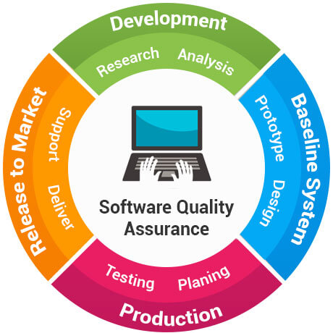

The plan identifies the SQA responsibilities of a team, lists the areas that need to be reviewed and audited. It also identifies the SQA work products.

SQA Objectives/Goals
The various objectives of SQA are as follows:

- Quality management approach.
- Measurement and reporting mechanisms.
- Effective software-engineering technology.
- A procedure to assure compliance with software-development standards where applicable.
- A multi-testing strategy is drawn.
- Formal technical reviews that are applied throughout the software process.

The major goals of SQA are as follows:

- SQA activities are planned.
- Non-compliance issues that cannot be resolved within the software project are addressed by senior management.
- Adherence of software products and activities to the applicable standards, procedures, and requirements is verified objectively.
- Affected groups and individuals are informed of SQA activities and results.

SQA objectives – during development
◆ Assuring an acceptable level of confidence that
the software will conform to functional technical
requirements.
◆ Assuring an acceptable level of confidence that
the software will conform to managerial
scheduling and budgetary requirements.
◆ Initiation and management of activities for the
improvement and greater efficiency of software
development and SQA activities.
29SQA objectives – during maintenance
◆ Assuring an acceptable level of confidence that
the software maintenance activities will conform
to the functional technical requirements.
◆ Assuring an acceptable level of confidence that
the software maintenance activities will conform
to managerial scheduling and budgetary
requirements.
◆ Initiate and manage activities to improve and
increase the efficiency of software maintenance
and SQA activities.

Software Quality Assurance (SQA) is simply a way to assure quality in the software. It is the set of activities which ensure processes, procedures as well as standards suitable for the project and implemented correctly.
Software Quality Assurance is a process which works parallel to development of a software. It focuses on improving the process of development of software so that problems can be prevented before they become a major issue. Software Quality Assurance is a kind of an Umbrella activity that is applied throughout the software process.
Software Quality Assurance have:

- A quality management approach
- Formal technical reviews
- Multi testing strategy
- Effective software engineering technology
- Measurement and reporting mechanism
Major Software Quality Assurance Activities:
- SQA Management Plan:
Make a plan how you will carry out the sqa through out the project. Think which set of software engineering activities are the best for project.check level of sqa team skills.
- Set The Check Points:
SQA team should set checkpoints. Evaluate the performance of the project on the basis of collected data on different check points.
- Multi testing Strategy:
Do not depend on single testing approach. When you have lot of testing approaches available use them.
- Measure Change Impact:
The changes for making the correction of an error sometimes re introduces more errors keep the measure of impact of change on project. Reset the new change to change check the compatibility of this fix with whole project.
- Manage Good Relations:
In the working environment managing the good relation with other teams involved in the project development is mandatory. Bad relation of sqa team with programmers team will impact directly and badly on project. Don’t play politics.
Benefits of Software Quality Assurance (SQA):
- SQA produce high quality software.
- High quality application saves time and cost.
- SQA is beneficial for better reliability.
- SQA is beneficial in the condition of no maintenance for long time.
- High quality commercial software increase market share of company.
- Improving the process of creating software.
- Improves the quality of the software.
Disadvantage of SQA:
There are a number of disadvantages of quality assurance. Some of them include adding more resources, employing more workers to help maintain quality and so much more.

Evaluation of Software Quality

software quality is as old as software construction and the concern for quality products arises with the design of error-free programs as well as efficiency when used.Research to improve the quality of software is generated due to users demand for software products with increasing quality. Actually, this is considered an engineering discipline .According to the IEEE Standard Glossary of Software Engineering Terminology ,the quality of software products is defined as
- the degree to which a system, component or process meets specified requirements and
- the degree to which a system, component or process meets the needs or expectations of a user.
An acceptable definition for a software product,given by Xu ,was “a packaged software component configuration or a software-based service that may have auxiliary components and which is released and exchanged in a specific market". Here packaged components refer to all kinds of programs. The software product takes different forms: small, COTS (Commercial Off-The-ShelfComponents), packed software, large commercial software, open source software and services In this paper we focus on the quality of the software product, that is,in the final product rather than on the processes that lead to its construction, even though they are closely related.The use of models is an acceptable means to support quality management software products. According to ISO/IEC IS 9126-1 a quality model is "the set of characteristics, and the relationships between them that provides the basis for specifying quality requirements and evaluation". The models to evaluate the quality of software have been constructed defining the fundamental factors (also called characteristics), and within each of them the sub factors (or sub characteristics). Metrics are assigned to each sub factor for the real evaluation.

Example
◆ Quality requirement – The product will be easy
to use
◆ Quality factor(s) – Usability (An attribute that
bears on the effort needed for use and on the
assessment of such use by users)
◆ Quality subfactors – Understandability, ease of
learning, operability, communicativeness
36Example - Subfactors
◆ Understandability
◆ The amount of effort required to understand software
◆ Ease of learning
◆ The degree to which user effort required to learn how to use the
software is minimized
◆ Operability
◆ The degree to which the effort required to perform an operation
is minimized
◆ Communicativeness
◆ The degree to which software is designed in accordance with the
psychological characteristics of users
37Example - Metrics
◆ Understandability ◆ Learning time: Time for new user to gain basic understanding of
features of the software
◆ Ease of learning ◆ Learning time: Time for new user to learn how to perform basic
functions of the software
◆ Operability ◆ Operation time: Time required for a user to perform operation(s)
of the software
◆ Communicativeness ◆ Human factors: Number of negative comments from new users
regarding ergonomics, human factors, etc.
38

SQ factor model

McCall Quality Model is the first quality model which was introduced. It is proposed by Jim McCall in the year 1977. He tried to build up the gap between the user and the developer by approaching quality factors from the both perspective. This quality model mainly focused towards system development .McCall defined 11 quality factors and 41 metrics in his quality model. McCall divided the 11 quality factors into three aspects.

Those are:

- PRODUCT REVISION: Product revision helps to increase the ability to change the product. It has a big role to manipulate the changing software product.
The quality factors are: •
Maintainability: Product that are easily maintainable and user has to spent money in maintenance.
Maintainability refers to the easiness of maintaining a software system. McCall et al. defines Maintainability as The cost of localizing and correcting errors'. Software maintenance includes the modification of the software for correction of errors, called as corrective maintenance. Besides that maintenance includes modification of system due to environment change such as upgrade of the system software, called as adaptive maintenance. Ghezzi et al. [64] also believes that maintenance is perfective maintenance, it involves changing the software to improve its quality by adding new functions, improving the performance of the application, making it easier to use, etc. Perfective maintenance could be initiated by the customer request or due to an idea of improvement by the developer. Legacy software could be another reason of maintainability. Legacy software is software which already exists and is generally old, developed with older technology, obsolete language and such software should either be repaired or evolved. Repairable software allows fixing of defects whereas evolvable ones allow changes that enable it to satisfy new requirements. Earlier maintenance was viewed as bug fixing but later it is realized that it is more of enhancing the product with features. There are no specific means of measuring maintainability. Pressman proposed a simple time oriented metric as 'Mean Time To Change'. It is the time taken to analyze the change request, design an appropriate modification, implement the change, test it and distribute the change to all users. Maintainable programs have a lower Mean Time To Change. •
Flexibility: Product should be flexible enough to change with environment. Flexibility has three dimensions, those are changeable, time and cost. •
McCall et al. [117] defines flexibility as 'the cost of product modification'. Flexibility is adaptability. In other words it is being able to change or reconfigure the user interface to suit user's preferences. The ability to meet the upcoming requirements of customer, without much stress is flexible software.
Testability: It provides the intermediate results of computations which are predefined to assist testing.
McCall et al. believes that 'the cost of program testing for the purpose of safeguarding is that the specific requirements are met'. Testing is associated with quality factor as a major criterion of quality . Most of the researchers in the field of testing, have concluded four stages of testing namely Item testing, Integration testing. System testing and Acceptance testing. Item testing - tests components individually. Integration testing-tests components when worked in environment of modules. System testing-tests the software (completely), to be sure that it is developed without errors. Acceptance testing-the customer tests the software, before incorporating it into its working. A number of testing strategies are employed for testing such as functional (Black Box), structural (White Box) and residual defect estimation. Techniques used to implement strategies are top down, bottom up and stress testing.

- PRODUCT OPERATION: The main function of product operation is to quickly understand, operate and provide the result. It gives us an overview of the whole product operation.
The quality factors are: •
Correctness: It helps to free the product from error or fault, and confirms it standard. So it can be said the degree to which a system is free from defects. •
Correctness factor implements the specified user's requirements. McCall et al. defines it as 'the extent to which a program fulfils its specification' . Ghezzi et al. believes that correctness is achieved, if stated functional requirements are met. Further, correctness can be improved by using standard proven algorithms or libraries of standard modules. Correctness is established through testing, program inspection, static program analyzers and verification mechanisms. Pressman refers to correctness as the degree to which software performs its required function.

Reliability: The product should be reliable enough to use. We can get the reliability of the product by simply making the ratio of number of production re- runs and production runs.
McCall et al. defines reliability as 'the extent it can fulfil its specific function'. Reliability is the ability of a product or component to continue to perform its intended role over a period of time to pre-defined conditions. At times reliability is measured in terms of the mean time between failures, the mean time to repair, mean time to recover, the probability to failure and availability of the solution. A dependable component is reliable. •

Efficiency: Efficient enough to remove defects. McCall et al. Believed that efficiency is the Volume of code or computer resources (e.g. Time or external storage) needed for a program so that it can fulfil its function'. The statement is concerned with the efficient use of computer code to perform processes and the efficient use of storage resources . While developing software, suitable programming language should be selected, along with advanced operating system as it increases the software efficiency, improves system performance and supports background operations. While designing the software, techniques to minimise data redundancy and algorithms to optimize process time should be adopted, for which cohesion, coupling and normalization factors be considered.
•

Integrity: It provides an unique access, and protect from illegal access. McCall et al. defines integrity as the 'extent to which illegal access to the programs and data of a product can be controlled'. Pressman gives importance to integrity keeping in view cyber terrorists, hackers etc. He expressed integrity attribute as a measure to the system's ability to overcome intentional and accidental attempts to procure software and data. To measure integrity, two additional related attributes are exposed, namely threat and security. Threat is the probability that an attack of a specific type will occur within a given time. Security is the probability that an attack of a specific type will be repelled. Pressman concluded that integrity is definable in a formula given in equation
Integrity = X (l-(threat * (1 - security)))
where Threat is the probability of an attack of a specific type will occur within a given time. Security is the probability that the attack of a specific type will be repelled. Threat and security are summed over each type of attack. According to Ronan integrity applies control for preventing inaccurate data entering the system, prevent changes to the software. French highlighted that it should be insured that all data is processed, preserved, errors should be detected, corrected and reprocessed and frauds be prevented and detected. French ] further, suggested five different types of control namely Manual control. Data preparation control. Validation check control, Batch control and File controls. Ghezzi et al. also supports the above view by specifying that data should be validated while being input or updated. Few mechanisms to ensue integrity are: input data types can be validated, maximum/minimum range values can be imposed, concurrent access control mechanism can be applied, lost update problem can be plugged, deadlock problem can be prevented and read-lock and write-lock system can be used. Minimizing data redundancy and integrity features from Data Base Management System should be incorporated. All validation checks at the data input Identi^ing Software Quality Factors, Sub-Factors And Metrics For CBSD stage must be mentioned in requirement specification. Similarly safety specifications must be written in requirement specification. •

Usability: It gives us the calmness and comfort of software. Usability is an attempt to quantify ease-of-use and can be measured in terms of suitability, learn ability and adaptability. McCall et al. defines usability, factor as The Cost/effort to learn and handle a product'. Usability is concerned with software operations and environment in today's world. The ease with which the software is used, learned and mastered is given importance for software operations. Further, screen design, feed backs, error messages, system performance, ability to reverse the user's last action etc. lead to software quality determining phase for the user's view. Similarly, use of input devices and output devices set the tone for environment. Even lighting, space, humidity, noise, etc. are part of the desired environment. In other words, a software component is usable if it finds humans who use it easily. Usability is subjective in nature. User friendliness parameters change from one user to another user. A non programmer may appreciate the use of menus, while a programmer may like to type a textual command. Hence, the user interface is an important criterion of user friendliness .

- PRODUCT TRANSITION: The main purpose of product transition is to increase the capacity of adaption of a software in any environment.
The quality factors are: •

Portability: It increases the capability to transmit the software from one to another platform.•
Reusability: The ability to reuse the product several time.•
Interoperability: The major software components work together.

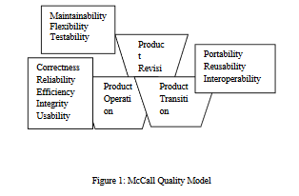

McCall’s Model vs. Alternative Models

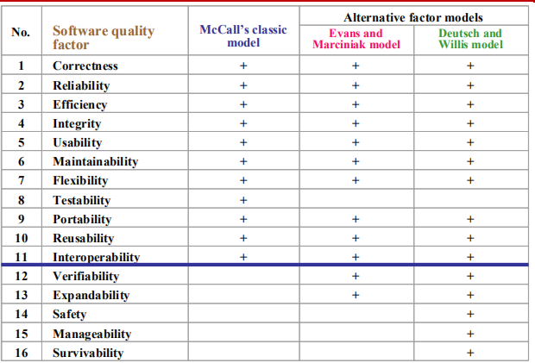

Identifying Software Quality Sub-factors :

The above identified software quality factors are non-quantifiable. Factors, subjective in nature, need to be measured to evaluate the quality. There is a necessity to break the quality factors into segments comprising of sub-factors. Software quality sub-factors are the characteristics that define quality factors. Further, quality factors may be divided into independent characteristics. The sub-factor perspective of the software quality is used for proposing the quality assurance framework. The various sub-factors for above mentioned quality factors, based on the number of studies, opinion of researchers in the past and interpretation are discussed below:

Efficiency: Efficiency factor means the product's ability to offer sufficient efficiency and using reasonable amount of resources when product is being used in specified environment.

Maintainability: Maintainability quality factor implies the product ability to be changeable, maintainable and updatable.

Portability : A portability factor means the products ability to be portable from one environment to another.

Reliability: Reliability attribute means the rate to which the product or component executes its functions under stated conditions in specified period of time.

Usability: Usability quality factor covers the product's ability to allow specified users to complete the needed task in defined context of use.

Identifying Software Quality Metrics:

The contribution of metrics to the purpose of software quality is understood and fully recognized by the software engineering community in general and particularly emphasized by the software quality community . Process and product metrics help in managing activities, such as scheduling, costing, staffing and controlling. Also, the engineering activities such as analyzing, designing, coding, documentation and testing are helped by the software metrics. Since the early days of computer science many approaches quantifying the internal structure of procedural software system have emerged . Some of those traditional metrics can still be used with the object-oriented paradigm, especially at the method level such as Lines Of Code (LOG) and Number of Methods . However, the need to quantify the distinctive features of object-oriented paradigm gave birth, in recent years, to new metric suites. The core object-oriented features include inheritance, encapsulation, abstraction and polymorphism. Most of the suites are yet to be experimentally validated for object-oriented features. This validation step usually consists of correlation studies between internal (design) and external (attributes) . Software metrics is the measuring property or attribute to measure quality of a software object related to software project of any size. Object-oriented approach is capable of classifying the problem in terms of objects and provides paybacks like efficiency, maintainability, reliability, portability and usability. Object-oriented metrics are useless if they are not mapped to software quality parameters. There are numerous quality metric suites available to predict quality of the software namely CK, MOOD, Lorenz and Kidd and Li Suite.

CK suite comprised of six metrics namely. Weighted Methods per Class (WMC), Response For a Class (RFC), Lack of Cohesion of Methods (LOOM), Depth of Inheritance Tree (DIT), Number Of Children (NOC) and Coupling Between Object classes (CBO). The metrics comprised in MOOD metrics are Method Hiding Factor (MHF), Attribute Hiding Factor (AHF), Method Inheritance Factor (MIF), Attribute Inheritance Factor (AIF), Polymorphism Factor (PF) and Coupling Factor (CF). The Lorenz and Kidd suite had three categories of metrics namely, Class Size Metrics, Class Inheritance Metrics and Class Internals Metrics. Each of these groups further contained metrics which are merely variables for counting. The Class Size Metrics had metrics each for counting- the Number of Public Methods (NPM), Number Of Methods (NOM), Number of Public Variables (NPV), Number of Variables per class (NV), Number of Class Variables (NCV) and Number of Class Methods (NCM). For the Class Inheritance Metrics one metrics each for counting- Number of Methods Inherited (NMI), Number of Methods Overridden (NMO) and Number of New Methods (NNA) is assigned. The Class Internals Metrics had metrics to count Average Parameters per Method (APM) and Specialization IndeX (SIX). The Li suite had six metrics namely, Number of Ancestor Classes (NAC), Number of Descendent Classes (NDC), Number of Local Methods (NLM), Class Method Complexity (CMC), Coupling Through Abstract data (CTA) and Coupling Through Message passing (CTM). The Lorenz and Kidd suite and Li suite had metrics for totalling purposes.
Based on the review of the existing software metrics suite, a list of parameters is defined to accept or discard software metric. Lacking any of these properties will result in an inapplicable quality metrics.

a)Precisely defined metrics: Ambiguity in metrics definition allows many interpretations for the same metric. A mathematical formula or a clear explanation of the 97 Identifying Software Quality Factors, Sub-Factors And Metrics For CBSD method of calculation of the metric should exist. All the CK suite metrics except one (LCOM) have definite mechanism to compute the metrics. LCOM had ambiguity in its computing formula .
b) Empirically validated software quality metrics: Metrics suites without validation are always in doubt concerning their correctness. The MOOD metrics suite and CK metrics suite have been validated in several studies and respectively. Empirical validations for the Lorenz and Kidd metrics suite and for Li suite are lacking.
c) Interpretation of metrics: Lord Kevin quoted "The degree to which you can express something in numbers is the degree to which you really understand it" is self explanatory to state that numbers do not have a meaning of their own, till the values are interpreted to make decisions. The Li suite and Lorenz and Kidd suite face an uphill task, number values exist but are not able to infer. Each metrics of CK and MOOD have interpretation for object-oriented characteristics e.g. DIT, MIF and AlF for inheritance; CBO for coupling; AHF and MHF for data abstraction; Polymorphism is represented by PF.

The SQA system

Software Quality Assurance (SQA) is a set of activities for ensuring quality in software engineering processes. It ensures that developed software meets and complies with the defined or standardized quality specifications. SQA is an ongoing process within the Software Development Life Cycle (SDLC) that routinely checks the developed software to ensure it meets the desired quality measures.
SQA practices are implemented in most types of software development, regardless of the underlying software development model being used. SQA incorporates and implements software testing methodologies to test the software. Rather than checking for quality after completion, SQA processes test for quality in each phase of development, until the software is complete. With SQA, the software development process moves into the next phase only once the current/previous phase complies with the required quality standards. SQA generally works on one or more industry standards that help in building software quality guidelines and implementation strategies.
It includes the following activities −
- Process definition and implementation
- Auditing
- Training
Processes could be −
- Software Development Methodology
- Project Management
- Configuration Management
- Requirements Development/Management
- Estimation
- Software Design
- Testing, etc.
Once the processes have been defined and implemented, Quality Assurance has the following responsibilities −
- Identify the weaknesses in the processes
- Correct those weaknesses to continually improve the process

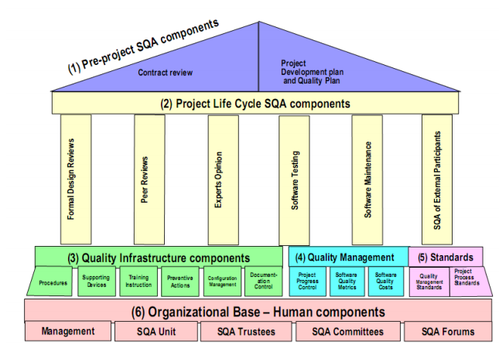

Components of SQA System
An SQA system always combines a wide range of SQA components. These components can be classified into the following six classes −

Pre-project component

This assures that the project commitments have been clearly defined considering the resources required, the schedule and budget; and the development and quality plans have been correctly determined.

Project lifecycle component
A project lifecycle usually comprised of two stages:
Development Stage
In the Development Stage Component, Software Quality Assurance help to identify the design and programming errors. Its Components are divided into the following sub-classes: Reviews, Expert Opinions, and Software Testing.
Operation Maintenance Stage
In Operation Maintenance Stage, the Software Quality Assurance components include the Development lifecycle component along with specialized components whose aim is to improve the maintenance tasks.

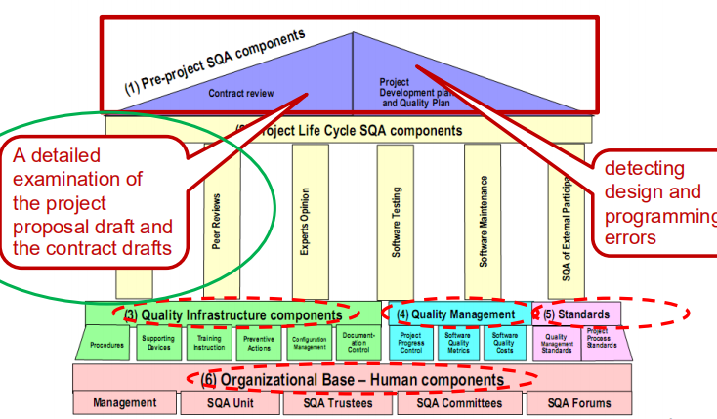

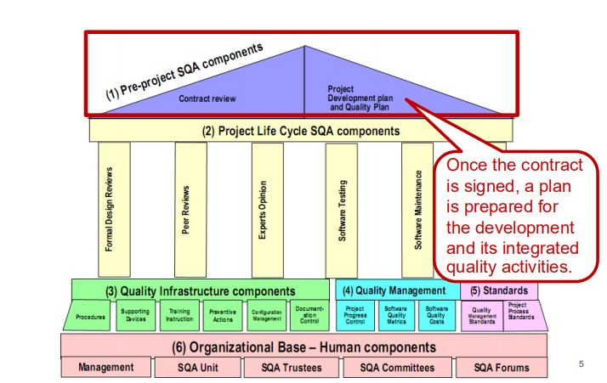

Components of project life cycle activities assessment
The project life cycle is composed of two stages: the development life cycle stage and the operation–maintenance stage.
The development life cycle stage components detect design and programming errors. Its components are divided into the following sub-classes: Reviews, Expert opinions, and Software testing.
The SQA components used during the operation–maintenance phase include specialized maintenance components as well as development life cycle components, which are applied mainly for functionality to improve the maintenance tasks.

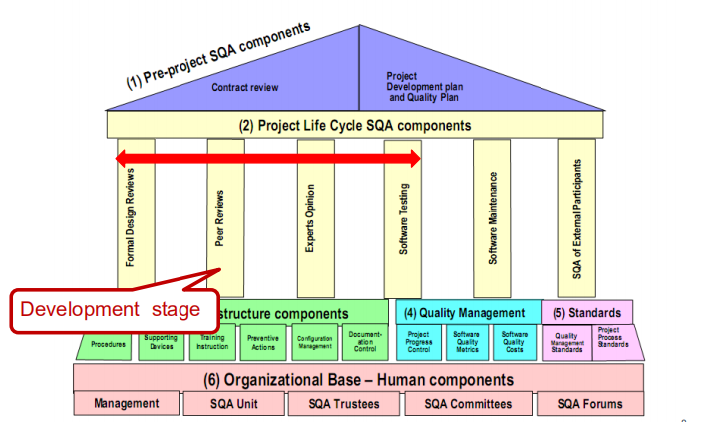

Components of infrastructure error prevention and improvement
The main objective of these components, which is applied throughout the entire organization, is to eliminate or at least reduce the rate of errors, based on the organization’s accumulated SQA experience.

Components of software quality management
This class of components deal with several goals, such as the control of development and maintenance activities, and the introduction of early managerial support actions that mainly prevent or minimize schedule and budget failures and their outcomes.

Components of standardization, certification, and SQA system assessment
These components implement international professional and managerial standards within the organization. The main objectives of this class are utilization of international professional knowledge, improvement of coordination of the organizational quality systems with other organizations, and assessment of the achievements of quality systems according to a common scale. The various standards may be classified into two main groups: quality management standards and project process standards.

Organizing for SQA – the human components
The SQA organizational base includes managers, testing personnel, the SQA unit and the persons interested in software quality such as SQA trustees, SQA committee members, and SQA forum members. Their main objectives are to initiate and support the implementation of SQA components, detect deviations from SQA procedures and methodology, and suggest improvements.

Pre-project Software Quality Components
These components help to improve the preliminary steps taken before starting a project. It includes −
- Contract Review
- Development and Quality Plans

Contract Review
Normally, a software is developed for a contract negotiated with a customer or for an internal order to develop a firmware to be embedded within a hardware product. In all these cases, the development unit is committed to an agreed-upon functional specification, budget and schedule. Hence, contract review activities must include a detailed examination of the project proposal draft and the contract drafts.
Specifically, contract review activities include −

Clarification of the customer’s requirements

Review of the project’s schedule and resource requirement estimates

Evaluation of the professional staff’s capacity to carry out the proposed project

Evaluation of the customer’s capacity to fulfil his obligations

Evaluation of development risks

Development and Quality Plans
After signing the software development contract with an organization or an internal department of the same organization, a development plan of the project and its integrated quality assurance activities are prepared. These plans include additional details and needed revisions based on prior plans that provided the basis for the current proposal and contract.
Most of the time, it takes several months between the tender submission and the signing of the contract. During these period, resources such as staff availability, professional capabilities may get changed. The plans are then revised to reflect the changes that occurred in the interim.
The main issues treated in the project development plan are −
- Schedules
- Required manpower and hardware resources
- Risk evaluations
- Organizational issues: team members, subcontractors and partnerships
- Project methodology, development tools, etc.
- Software reuse plans
The main issues treated in the project’s quality plan are −

Quality goals, expressed in the appropriate measurable terms

Criteria for starting and ending each project stage

Lists of reviews, tests, and other scheduled verification and validation activities

Reviews
◆ The design phase of the development process
produces a variety of documents. The printed
products include design reports, software test
documents, software installation plans and
software manuals, among others.
Reviews can be categorized as
◆ Formal design reviews
◆ Peer reviews
◆ Experts reviews
92.1 Formal design reviews
◆ The committee is composed of senior
professionals, including the project leader and,
usually, the department manager, the chief
software engineer, and heads of other related
departments.
◆ The review report itself includes a list of required
corrections (termed “action items”).
102.1 Formal design reviews
When a design review committee sits in order to decide
upon the continuation of the work completed so far, one
of the following options is usually open for consideration
◆ Immediate approval of the current document and continuation to
the next development phase.
◆ Approval to proceed to the next development phase after all the
action items have been completed and inspected by the
committee’s representative.
◆ An additional review is required and scheduled to take place
after all the action items have been completed and inspected by
the committee’s representative.
Peer reviews
◆ Peer reviews (inspections and walkthroughs) are
directed at reviewing short documents, chapters
or parts of a report, a coded printout of a
software module.
◆ Usually, the reviewers are all peers, not
superiors, who provide professional assistance
to colleagues.
◆ The main objective of inspections and
walkthroughs is to detect as many design and
programming faults as possible.
◆ The output is a list of detected faults and, for
inspections, also a defect summary and
statistics to be used as a database for reviewing
and improving development methods.
Expert opinions
Expert opinions support quality assessment efforts by
introducing additional external capabilities into the
organization’s in-house development process. Turning to
outside experts may be particularly useful in the
following situations
◆ Insufficient in-house professional capabilities in a given
area.

◆ In small organizations in many cases it is difficult to find
enough suitable candidates to participate in the design
review teams.
◆ In cases of major disagreement among the
organization’s senior professionals, an outside expert
may support a decision.

Software testing
Software testing is an investigation conducted to provide stakeholders with information about the quality of the software product or service under test.\Software testing can also provide an objective, independent view of the software to allow the business to appreciate and understand the risks of software implementation. Test techniques include the process of executing a program or application with the intent of finding software bugs (errors or other defects), and verifying that the software product is fit for use.
Software testing involves the execution of a software component or system component to evaluate one or more properties of interest. In general, these properties indicate the extent to which the component or system under test:
- meets the requirements that guided its design and development,
- responds correctly to all kinds of inputs,
- performs its functions within an acceptable time,
- it is sufficiently usable,
- can be installed and run in its intended environments, and
- achieves the general result its stakeholders desire.
As the number of possible tests for even simple software components is practically infinite, all software testing uses some strategy to select tests that are feasible for the available time and resources. As a result, software testing typically (but not exclusively) attempts to execute a program or application with the intent of finding software bugs (errors or other defects). The job of testing is an iterative process as when one bug is fixed, it can illuminate other, deeper bugs, or can even create new ones.
Software testing can provide objective, independent information about the quality of software and risk of its failure to users or sponsors.
Software testing can be conducted as soon as executable software (even if partially complete) exists. The overall approach to software development often determines when and how testing is conducted. For example, in a phased process, most testing occurs after system requirements have been defined and then implemented in testable programs. In contrast, under an agile approach, requirements, programming, and testing are often done concurrently.

Maintenance components
◆ Software maintenance services vary in range and are provided
for extensive periods, often several years. These services fall
into the following categories:
◆ Corrective maintenance – User’s support services and
correction of software code and documentation failures
◆ Adaptive maintenance – Adaptation of current software to
new circumstances and customers without changing the basic
software product.
◆ Functionality improvement maintenance – The functional
and performance related improvement of existing software,
carried out with respect to limited issues.
◆ There is another complete procedure and for the maintenance.

Quality Infrastructure Components
Software quality management procedures class of sources
Project progress reports
Software quality metrics reports
Software quality cost reports
Proposals of staff members.

◆ Procedures and work instructions
◆ Accumulated experience and knowledge
◆ Supporting devices
◆ Templates and checklists
◆ Staff training, retraining, and certification
◆ Key to have efficient and quality performance
◆ Preventive and corrective actions
◆ Record good and bad practices
◆ Configuration management ◆ Version control
◆ Documentation control

Supporting quality devices
* Templates and checklists
■ Saving the time required to define the structure of the various
documents or prepare lists of subjects to be reviewed.
■ Contributing to the completeness of the documents and
reviews.
■ Improving communication between development team and
review committee members by standardizing documents and
agendas.
.
35Staff training, instruction and certification
* Templates and checklists
■ Training new employees and retraining those employees who
have changed assignments.
■ Continuously updating staff with respect to professional
developments and the in-house, hands-on experience acquired.
■ Certifying employees after their knowledge and ability have
been demonstrated.
36Preventive and corrective actions
* Templates and checklists
■ Implementation of changes that prevent similar failures in the
future.
■ Correction of similar faults found in other projects and among
the activities performed by other teams.
■ Implementing proven successful methodologies to enhance
the probability of repeat successes.

Several national and international standards institutes, professional and industry-oriented organizations have been involved in the development of SQA standards.
The following institutes and organizations are the main developers of SQA and software engineering standards −
- IEEE (Institute of Electrical and Electronics Engineers) Computer Society
- ISO (International Organization for Standardization)
- DOD (US Department of Defense)
- ANSI (American National Standards Institute)
- IEC (International Electro Technical Commission)
- EIA (Electronic Industries Association)
These organizations provide updated international standards to the quality of professional and managerial activities performed in software development and maintenance organizations.
They also provide SQA certification through independent professional quality audits. These external audits assess achievements in the development of SQA systems and their implementation. Certification, which is granted after the periodic audits, will be valid only until the next audit, and therefore must be renewed. At present, the ISO 9000 Certification Service is the most prominent provider of SQA certification in Europe and other countries.
They also provide the tools for self-assessment of an organization’s SQA system and its operation. The Capacity Maturity Model (CMM) developed by the Software Engineering Institute (SEI), Carnegie Mellon University, and ISO/IEC Std 15504 are the examples of this approach.

SQA Standards
Software quality assurance standards can be classified into two main classes −

Software quality assurance management standards, including certification and assessment methodologies (quality management standards)

Software project development process standards (project process standards)

Quality Management Standards
These focus on the organization’s SQA system, infrastructure and requirements, while leaving the choice of methods and tools to the organization. With quality management standards, organizations can steadily assure that their software products achieve an acceptable level of quality.
Example − ISO 9000-3 and the Capability Maturity Model (CMM)

Project Process Standards
These focus on the methodologies for implementing the software development and maintenance projects. These standards include the following −
- The steps to be taken
- Design documentation requirements
- Contents of design documents
- Design reviews and review issues
- Software testing to be performed
- Testing topics
Naturally, due to their characteristics, many SQA standards in this class can serve as software engineering standards and vice versa.

Software Quality Management Components
This class of component consists of controlling development and maintenance activities. These components establish the managerial control of software development projects. The management component aims to prevent the project from going over budget and behind schedule.
The management components include:
- Project Progress Control
- Software Quality Metrics
- Software Quality Costs
Project progress control (also, maintenance contract
control)
◆ Detect deviations from the plan
◆ Resource usage, schedules, risk management activities, budget
◆ Software quality metrics
◆ Productivities, faults density, etc.
◆ Software quality costs
◆ Control cost + failure cost

The components of project progress control
■ Control of risk management activities
■ Project schedule control
■ Project resource control
■ Project budget control.

Control of risk management activities
This refers to the software development
risk items identified in the preproject stage,
those listed in contract review and project
plan documents, together with other risk
items identified throughout the project’s
progress.

Project schedule control
This deals with the project’s compliance
with its approved and contracted
timetables. Follow-up is based mainly
on milestones, which are set (in part)
to facilitate identification of delays in
completion of planned activities.
Project resource control
This focuses on professional human resources
but it can deal with other assets as well. For
real-time software systems and firmware,
software development and testing facilities
resources typically demand the most exacting
control.
Project budget control
■ Human resources
■ Development and testing facilities
■ Purchase of COTS software
■ Purchase of hardware
■ Payments to subcontractors.

Progress control of internal projects and
external participants
Project progress control is initiated in order to
provide management with a comprehensive
view of all the software development activities
carried out in an organization. Nevertheless, in
most organizations, project control provides, for
different reasons, a limited view of the progress
of internal software development and an even
more limited view of the progress made by
external participants.
Implementation of project progress control
regimes
■ The allocation of responsibility for
performance of the process control tasks that are
appropriate for the project’s characteristics,
including size:
■ Management audits of project progress, which
deal mainly with:
(1) how well progress reports
are transmitted by project leaders and by lower
to upper-level managers, and
(2) the specific
management control activities to be initiated.

Computerized tools for project progress
control

There are a large variety of new computer tools for the construction project management industry. Most of these tools are standard practices that have been developed in the past but are now transferred to web-based applications. This web-based application approach has significantly improved project team communication and collaboration. Because of the acceleration of communication and collaboration, projects are being done quicker and with a higher degree of satisfaction.
Very few solutions will perform all of the functions needed for project management. Be wary of those “total enterprise” systems that claim that they can do it all. Most of them have built their business in one area such as MPS and Prolog Manager, which is the market leader. They then try to bundle other total enterprise products such as scheduling. Their Prolog Manager is good, but their scheduling is marginal. Same with Primavera. This is why companies still use a variety of software solutions. The best practice in selecting software is to identify the needs of the project, and then find the solutions that best fit those needs.

Examples of services that computerized tools
can provide are as follows.
Control of risk management activities
Project schedule control
Project resource control
Project budget control
Control of risk management activities :
Lists of software risk items by category
and their planned solution dates.
Lists of exceptions of software risk
items – overrun solution dates that
can affect the project completion date.

Project schedule control :
Classified lists of delayed activities.
Classified lists of delays of critical activities – delays
that can, if not corrected, affect the project’s completion
date.
Updated activity schedules generated according to
progress reports and correction measures applied – for
teams, development units, etc.
Classified lists of delayed milestones.
Updated milestone schedules generated according
to progress reports and applied correction measures –
for teams, development units, etc.

Project resource control :
Project resources allocation plan – for activities and
software modules, for teams, development units,
designated time periods, etc.
Project resources utilization – by period or
accumulated – as specified above.
Project resources utilization exceptions – by period
or accumulated – as specified above.
Updated resources allocation plans generated
according to progress reports and correction measures
applied.
Project budget control :
Project budget plans – by activity and
software module, for teams, development units,
designated time periods, etc.
Project budget utilization reports – by period
or accumulated – as specified above.
Project budget utilization deviations – by
period or accumulated – as
specified above.
Updated budget plans generated according
to progress reports and correction measures
applied.

Software Quality Metrics:
Software metrics can be classified into three categories −

Product metrics − Describes the characteristics of the product such as size, complexity, design features, performance, and quality level.

Process metrics − These characteristics can be used to improve the development and maintenance activities of the software.

Project metrics − This metrics describe the project characteristics and execution. Examples include the number of software developers, the staffing pattern over the life cycle of the software, cost, schedule, and productivity.

Some metrics belong to multiple categories. For example, the in-process quality metrics of a project are both process metrics and project metrics.
Software quality metrics are a subset of software metrics that focus on the quality aspects of the product, process, and project. These are more closely associated with process and product metrics than with project metrics.
Software quality metrics can be further divided into three categories −
- Product quality metrics
- In-process quality metrics
- Maintenance quality metrics

Product Quality Metrics
This metrics include the following −
- Mean Time to Failure
- Defect Density
- Customer Problems
- Customer Satisfaction

Mean Time to Failure
It is the time between failures. This metric is mostly used with safety critical systems such as the airline traffic control systems, avionics, and weapons.

Defect Density
It measures the defects relative to the software size expressed as lines of code or function point, etc. i.e., it measures code quality per unit. This metric is used in many commercial software systems.

Customer Problems
It measures the problems that customers encounter when using the product. It contains the customer’s perspective towards the problem space of the software, which includes the non-defect oriented problems together with the defect problems.
The problems metric is usually expressed in terms of Problems per User-Month (PUM).
PUM = Total Problems that customers reported (true defect and non-defect oriented
problems) for a time period + Total number of license months of the software during
the period
Where,
Number of license-month of the software = Number of install license of the software ×
Number of months in the calculation period
PUM is usually calculated for each month after the software is released to the market, and also for monthly averages by year.

Customer Satisfaction
Customer satisfaction is often measured by customer survey data through the five-point scale −
- Very satisfied
- Satisfied
- Neutral
- Dissatisfied
- Very dissatisfied
Satisfaction with the overall quality of the product and its specific dimensions is usually obtained through various methods of customer surveys. Based on the five-point-scale data, several metrics with slight variations can be constructed and used, depending on the purpose of analysis. For example −
- Percent of completely satisfied customers
- Percent of satisfied customers
- Percent of dis-satisfied customers
- Percent of non-satisfied customers
Usually, this percent satisfaction is used.

In-process Quality Metrics
In-process quality metrics deals with the tracking of defect arrival during formal machine testing for some organizations. This metric includes −
- Defect density during machine testing
- Defect arrival pattern during machine testing
- Phase-based defect removal pattern
- Defect removal effectiveness

Defect density during machine testing
Defect rate during formal machine testing (testing after code is integrated into the system library) is correlated with the defect rate in the field. Higher defect rates found during testing is an indicator that the software has experienced higher error injection during its development process, unless the higher testing defect rate is due to an extraordinary testing effort.
This simple metric of defects per KLOC or function point is a good indicator of quality, while the software is still being tested. It is especially useful to monitor subsequent releases of a product in the same development organization.

Defect arrival pattern during machine testing
The overall defect density during testing will provide only the summary of the defects. The pattern of defect arrivals gives more information about different quality levels in the field. It includes the following −

The defect arrivals or defects reported during the testing phase by time interval (e.g., week). Here all of which will not be valid defects.

The pattern of valid defect arrivals when problem determination is done on the reported problems. This is the true defect pattern.

The pattern of defect backlog overtime. This metric is needed because development organizations cannot investigate and fix all the reported problems immediately. This is a workload statement as well as a quality statement. If the defect backlog is large at the end of the development cycle and a lot of fixes have yet to be integrated into the system, the stability of the system (hence its quality) will be affected. Retesting (regression test) is needed to ensure that targeted product quality levels are reached.

Phase-based defect removal pattern
This is an extension of the defect density metric during testing. In addition to testing, it tracks the defects at all phases of the development cycle, including the design reviews, code inspections, and formal verifications before testing.
Because a large percentage of programming defects is related to design problems, conducting formal reviews, or functional verifications to enhance the defect removal capability of the process at the front-end reduces error in the software. The pattern of phase-based defect removal reflects the overall defect removal ability of the development process.
With regard to the metrics for the design and coding phases, in addition to defect rates, many development organizations use metrics such as inspection coverage and inspection effort for in-process quality management.

Defect removal effectiveness
It can be defined as follows −
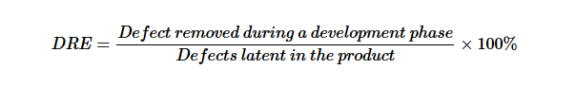
This metric can be calculated for the entire development process, for the front-end before code integration and for each phase. It is called early defect removal when used for the front-end and phase effectiveness for specific phases. The higher the value of the metric, the more effective the development process and the fewer the defects passed to the next phase or to the field. This metric is a key concept of the defect removal model for software development.

Maintenance Quality Metrics
Although much cannot be done to alter the quality of the product during this phase, following are the fixes that can be carried out to eliminate the defects as soon as possible with excellent fix quality.
- Fix backlog and backlog management index
- Fix response time and fix responsiveness
- Percent delinquent fixes
- Fix quality

Fix backlog and backlog management index
Fix backlog is related to the rate of defect arrivals and the rate at which fixes for reported problems become available. It is a simple count of reported problems that remain at the end of each month or each week. Using it in the format of a trend chart, this metric can provide meaningful information for managing the maintenance process.
Backlog Management Index (BMI) is used to manage the backlog of open and unresolved problems.
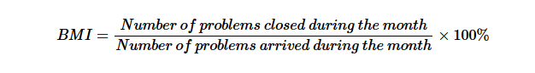

If BMI is larger than 100, it means the backlog is reduced. If BMI is less than 100, then the backlog increased.

Fix response time and fix responsiveness
The fix response time metric is usually calculated as the mean time of all problems from open to close. Short fix response time leads to customer satisfaction.
The important elements of fix responsiveness are customer expectations, the agreed-to fix time, and the ability to meet one's commitment to the customer.

Percent delinquent fixes
It is calculated as follows −

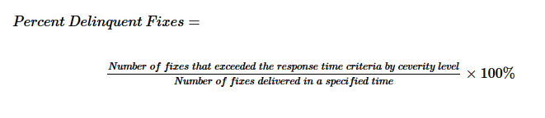

Fix Quality
Fix quality or the number of defective fixes is another important quality metric for the maintenance phase. A fix is defective if it did not fix the reported problem, or if it fixed the original problem but injected a new defect. For mission-critical software, defective fixes are detrimental to customer satisfaction. The metric of percent defective fixes is the percentage of all fixes in a time interval that is defective.
A defective fix can be recorded in two ways: Record it in the month it was discovered or record it in the month the fix was delivered. The first is a customer measure; the second is a process measure. The difference between the two dates is the latent period of the defective fix.
Usually the longer the latency, the more will be the customers that get affected. If the number of defects is large, then the small value of the percentage metric will show an optimistic picture. The quality goal for the maintenance process, of course, is zero defective fixes without delinquency.

Customer services are of two main types:

The array of software product metrics presented
here is classified as follows:
HD quality metrics
HD productivity and effectiveness metrics
Corrective maintenance quality metrics
Corrective maintenance productivity and
effectiveness metrics.

HD quality metrics :
HD calls density metrics – the extent of
customer requests for HD services as
measured by the number of calls.
Metrics of the severity of the HD issues
raised.
HD success metrics – the level of success in
responding to these calls. A success is
achieved by completing the required service
within the time determined in the service
contract.

HD productivity and effectiveness metrics
HD productivity metrics
HD effectiveness metrics

Corrective maintenance quality metrics
Software system failures density metrics –
deal with the extent of demand
for corrective maintenance, based on the
records of failures identified
during regular operation of the software
system.
Software system failures severity metrics –
deal with the severity of software system
failures attended to by the corrective
maintenance team.

Limitations of software metrics
Budget constraints in allocating the necessary
resources (manpower, funds, etc.) for
development of a quality metrics system and its
regular application.

Human factors, especially opposition of
employees to evaluation of their activities.

Uncertainty regarding the data’s validity,
rooted in partial and biased reporting.

About contracts
◆ Contracts are vitally important.
◆ Basis for considerable litigation when delivered software
does not perform as expected.
◆ Bad contracts arise out of poorly defined requirements
and unrealistic budgets and schedules. Preventive Quality
Assurance starts with a discussion of Contracts.
◆ Author discusses two contracts:a proposal draft contract
and contract draft.
◆ Purpose: to arrive at a realistic budget and timetable and
discovering pitfalls early.

RFPs in principle:

RFPs in principle
◆ Request for proposals (RFP) inform suppliers that an
organization is looking to procure and encourages them to
make their best effort.
◆ Present preliminary requirements for the service, and may
dictate to varying degrees the exact structure and format of the
supplier's response.
◆ Require the company to specify what it proposes to purchase. If
the requirements analysis has been prepared properly, it can be
incorporated quite easily into the Request document.
◆ Allow for wide distribution and response, therefore also alert
suppliers that the selection process is competitive.
◆ Ensure that suppliers respond factually to the identified
requirements.
◆ Generally expected to follow a structured evaluation and
selection procedure

Typical situations for contracts
◆ Participation in a tender
◆ We pay you $X to deliver this product…
◆ Proposal submission according to customer’s RFP
◆ Discussed. Common!
◆ Receipt of an order from a company’s customer
◆ Most common
◆ Internal request from another department in the
organization
◆ Very commonContract review stages
Carry out the Contract Review process in two stages:
◆ Review proposed draft prior to submission to potential
customer
◆ Review the final proposal draft and customer’s requirement
documents and explanations of requirements, costs, resources,
maybe with partners.
◆ Review of contract prior to signing
◆ Review draft on basis of the proposal and understandings
reached during the contract negotiation sessions.
A checklist is very helpful for assuring the full coverage
of relevant subjects!Contract review objectives
Proposal draft review objectives - 1
◆ Customer requirements clarified and documented
◆ Some documents (most) may well be vary vague. These vague items
must be clarified and spelled out clearly! Provide additional
supplementary documents.
◆ Alternative approaches for carrying out the project
examined
◆ Should be captured. “I thought you are going to do this….”
◆ Formal aspects of the relationship between the customer
and the software firm specified
◆ Extremely critical. How are communications to take place? Frequency?
How are deliverables deployed? Customer responsibilities? Customer
testing? Change control procedure identified?Contract review objectives

Proposal draft review objectives - 2
◆ Development risks identified
◆ HUGE area! Risk may be technical (don’t have know-how),
environmental (developed under unusual circumstance...), political,
social (different ethnic groups), personal (people get sick, die, have
babies, need assistance, etc.), project complexity, software
methodologies / technologies to be used…….
◆ Project resources and timetable adequately estimated
◆ Do we need subcontractors? What constraints might they have?
Global partners? Their constraints? Resource estimation and the
project’s budget: Does the software firm have the viability to deliver on
schedule?
◆ The firm’s capacity with respect to the project examined
◆ Availability of professional competence and development facilities? Contract review objectives
Proposal draft review objectives - 3
◆ The customer’s capacity to fulfill his commitments
examined
◆ How about the customer’s organization? Their financial capacities? Will
they be able to train new people on new system? Recruit new people?
Can they install and assume operational control for a delivered system?
Maintenance? Handover?
◆ Definition of Partner and Subcontractor Participation
◆ These conditions must be clearly defined. Payment schedules?
Cooperation between project management and teams?
Communications?
◆ Protection of proprietary rights defined
◆ Who owns the software? Especially critical for future use and
modification. Is this reusable software reused in other parts of the
software development firm? Consider proprietary files?Contract review objectives
Contract draft review objectives
◆ No unclarified issues remain in the contract draft
◆ All understandings reached subsequent to the proposal
are correctly documented

◆ No “new” changes, additions, or omissions that have not
been fully discussed have entered the contract draftContract Review Considerations
◆ Can be very exacting
◆ May focus on technical or organizational issues
◆ Thus different levels of effort and participation are often
needed depending on the nature of the contract
◆ Factors may affect the extent of a contract review
◆ Project magnitude (measured in man-months effort)
◆ Project technical complexity
◆ Familiarity with application domain by staff may affect extent of the
review
◆ Project organizational complexity – the larger the number of participants
(subcontractors, customers, developers, partners, etc), the greater .

For a major proposal

Software quality assurance (SQA) is becoming a critical issue in software development and maintenance. Software development organizations are dedicating significant resources to testing as their contribution to SQA. This paper discusses the existing organizational approaches to implementing testing practices. Nowadays, software development organizations are beginning to outsource the testing-related activities to organizations (testing factories) in order to reduce the resources dedicated to testing and increasing the quality and reliability of the final software products and services. A software factory needs a specific organizational model for its management. The organizational model must be composed of a testing process model and an organizational structure establishing the required roles, responsibilities and competences. This paper focuses on describing a proposed process model to manage a software factory. Finally, this paper introduces the current experiences obtained from the proposed model.

Major proposal is for projects characterized by at least:

1.Very large-scale project
2.Very high technical complexity
3.New professional area for the company
4.High organizational complexity

The difficulties of carrying out contract review for major proposal:
Time pressureUsually need to be performed within a short timeProper contract review may requires substantial professionalNeed to invest of substantial professional expertise (involve with factor time and also the budget)The potential contract review team members are very busy.The potential member of the contract review team are often senior staff members who usually committed to performing their regular Recommended step for implementing major contract review:
The careful planning of contract and steps are required for successful project. The steps are:
- The contract review should be scheduled.
- A team should carry out the contract review.
- A contract review team leader should be appointed.

The task for team leader are:
- Recruitment of the members
- Distribution of review task among members.
- Coordination between review team and proposal team.
- Coordination between members of the review team.
- Follow-up the activities and make sure compliance with the schedule.
- Summarization of the findings and their delivery to the proposal team

Review internal projects
Typical internal projects may be:
1.Administrative or operative software to be applied
internally
2.Software packages originally intended to be sold to the
public as “off-the-shelf” packages
3.Firmware to be embedded in the company’s products

4.Internal software development projects are not based on what would be considered a complete customer-supplier relationship.
5.In many case these project are based on general agreement. It follows that the developing unit will perform only a short and mild contract review or maybe none at all!.
6.We call this as loose relationship.
Disadvantages to customers
◆ Inadequate definition of project requirements
◆ Implementation deviates from the needed applications
◆ Low satisfaction
◆ Poor estimate of the required resources
◆ Unrealistic expectations about project feasibility
◆ Poor timetable
◆ Missing scheduled dates for beginning the distribution of new
products
◆ Inadequate awareness of development risks
◆ Customer unprepared for project risks and their consequences

Disadvantages to developers
◆ Inadequate definition of project requirements
◆ Higher change requirements
◆ Wasted resources due to introducing avoidable changes
◆ Poor estimate of the required resources
◆ Substantial deviations from budget
◆ Friction between units induced by requirements for budget .
◆ Poor timetable

◆ Development activities are under time pressures and suffer from
low quality
◆ Delays in freeing staff for their next project
◆ Inadequate awareness of development risks

◆ Tardy initiation of efforts to overcome difficulties

Project development and quality plan:

Imagine that you have been appointed as a head of a big project. As it often the case in the software industry, you come under serious time pressure from the very first day. Because you were MEMBER of the proposal team and participated in most of the meetings held with customer, you are confident that you know all that is necessary to do the job. You INTEND to use the proposal plans and internal documents that the team had prepared as your DEVELOPMENT and QUALITY plans. You are prepared to RELY on these materials because you know that the proposal and its estimates, including the timetable, staff requirements, list of project documents, scheduled design reviews, and list of development risk. By: MSMZYou therefore was a bit disappointed that at this CRUCIAL point of the project, the Development Department Manager demands that you immediately prepare new and separate project development plans (“Development Plan”) and project quality plan (“Quality Plan”). When you claim that the completed proposal could serve as the requested plans. BUT the manager still insists that they must be updated with new and more comprehensive topics should be added to plan. “By the way , don’t forget that a period of 7 months has gone between the proposal preparation and the final signing of the contract” mention by the manager.

you may discover that some team members will not be available at the scheduled dates due to delays in completion of their current assignment orThe consulting company that had agreed to provide professional support in a specialized and crucial area has gone bankrupt.These are example of two of problem that may arise.

Development Plan and Quality Plan :

In summary, project NEEDS Development Plan and Quality Plan:-Based on proposal material that have been re-examined and updatedMore comprehensive than the approved proposal, especially with on the schedule, resource estimates and development risk.Include additional subjects, absent from the approved proposal.

Objective:
After completing this chapter, you will be able to:Explain the objectives of a development plan and a quality plan.Identify the elements of development planIdentify the elements of a quality planDiscuss the importance of development and quality plans for small projects and also for internal projects.

Objective of Development Plan and Quality Plan:

Planning, as a process, has several objectives, each is meant to prepare enough foundation for the following:-
- Scheduling development activities
- Recruiting team members and allocating development resources
- Resolving development risk
4.Implementing required SQA activities
5.Providing management with data needed for project control.

Elements of the development plan:

Based on the proposal materials, the project development plan is prepared to fulfill the above objective. The following elements, each is applicable to different project component.

1.Project products
The development plan includes :
Design documents specifying dates of completion.
Software products (completion date and installation site)
Training task (dates, participants and sites)

2.Project interfaces
The development plan include:
Interfaces with existing software interface
Interface with other software /hardware development teams that are working in the same project.
Interfaces with existing hardware.

3.Project methodology and development tools to be applied at each phase of the project.

4.Software development standards and procedures.
A list should be prepared of the software development standards and procedures to be applied in project.

5.The mapping of the development process.
Involves providing detailed descriptions of each project phases. Activity descriptions include:-
Estimate of the activity duration
Description of each activities
Type of professional resources required.

6.Project milestones
For each milestone, its completion time and project products (document and code) are to be defined.

7.Project staff organization Comprises:-
Organizational structure (Project team and their task)
Professional requirements (Experience and cert)
Number of team members (According to each activities)
Names of team leaders and team members
Coordination with external participants

7.Development facilities 

Comprises:-
Organizational structure (Project team and their task)
Professional requirements (Experience and cert)
Number of team members (According to each activities)
Names of team leaders and team members
Coordination with external participants

8.Development facilities 
Required development facilities and the period required for its use.

- Development risk:
Technology gap (Lack of sufficient professional knowledge)
Staff shortage 
Interdependence of organizational (Supplier of specialized hardware/software not fulfill their obligation on schedule)

- Control methods
In order to control project implementation, the project manager apply a series of monitoring practices when preparing progress reports and coordinating meetings.

- Project cost estimation (Based on proposal costs estimates, followed by continuous relevance review).

Elements of the quality plan:
All or some of the following items, depending on the project, comprise the following elements:-
- Quality goals
Refer to developed software system’s substantive quality requirements.Preferably stated in the form of quantitative as opposed to qualitative measures.
Examples:-A software system to serve the help desk operations of an electrical appliance manufacture is to be developed. The help desk system (HDS) is intended to operate for 100 hours per week. The software quality assurance team was requested to prepare a list of Quantitative Quality Goals appropriate to certain qualitative requirements.

- Planned review activities
The plan should provide a complete listing of all planned review activities with the following determined for each activities:-
The scope of the review activityThe type of the review activity
The schedule of review activity
The specific procedures to be applied
Who is responsible for carrying out the review activities.

- Planned software tests
Include:-
The unit, integration or the complete system to be tested.
The type of testing activities, including software to be used, if any.The planned test schedule
The specific procedures to be applied
Who is responsible for carrying out the test.

4.Planned acceptance test for externally developed software:
Purchased software
Software developed by subcontractors
Customer-supplied software

5.Configuration management
Include:-
Configuration management tools
Configuration management procedures.

Development and Quality plan for small projects:

Does a project of only 40 working days’ duration, to be performed by one professional and completed within 12 weeks, justify the investment of a man-day in order to prepare full-scale development and quality plans?
Does a project to be implemented by three professionals, with a total investment of 30 man-days and completed within five weeks, require full-scale plans?

It should be clear that development and quality plan procedures applicable to large projects cannot be automatically applied to small projects.
Situations where STANDARD development and quality plan may or may not be required.
- Projects requiring 15 days –not required
- Project requiring 50 days where no significant software risk item had been identified –at project leader’s discretion
- Small project but complicated that need to be complete within 30 days, in which there is heavy penalty on not being completed on time-obligatory.

Recommended elements of development and quality plans for small projects

Development plan:
Project products, indicating deliverables
Project benchmarks
Development risks
Estimates of project cost
Quality plan:
Quality goals

Benefits of preparing development and quality plans for small projects
- Improvements in the developer’s understanding of the task.
- Greater commitment to complete the project as planned.
- Easier for management and customer to monitor and identify delays earlier on.
- Better understanding with respect to the
requirements and timetable between developer and customer.

Development and Quality plan for internal projects:
Benefits of preparing development and quality plans for internal projects to the software development department:
- Avoiding budget overruns.
- Avoiding damage to other projects due to the delays in releasing professional resources involved in internal project.
- Avoiding loss of market status caused by delayed
completion of external projects triggered by late completion of internal projects.

Benefits of preparing development and quality plans for internal projects to the internal customer:
- Smaller deviations from planned completion dates and smaller budget overruns.
- Better control of the development process including earlier detection of potential delays.
- Fewer internal delay damages.

Benefits of preparing development and quality plans for internal projects to the organization:
- Reduced risk of market loss due to late arrival of the product.
- Reduced risk of being sued for late supply of products.
- Reduced risk of requesting a budget
supplement.
4.Reduced risk of impairing the firm’s reputation.

Integrating quality activities in
the project life cycle

The first part of this chapter is dedicated to the various software development models in current use. The remaining sections deal with the objectives of the software quality assurance activities conducted throughout the project
life cycle, their integration in the development process, and the factors considered before applying them. One might inquire why not begin with SQA activities and omit the discussion of the software development models? This question is not simply rhetorical. Software development models provide a coordinated set of concepts and methodologies needed to implement software development. As such, they include definitions of the main activities needed for development, the appropriate sequence for their performance, and their milestones. By
deciding what models are to be applied, the project leader determines how the project will be carried out. Most quality assurance activities take place in conjunction with the completion or examination of activity milestones,
which require review of the product development activities previouslycompleted. Therefore, SQA professionals should be acquainted with the var
ious software engineering models in order to be able to prepare a quality plan that is properly integrated into the project plan.
The rest of the first part of the chapter deals with the factors affecting the choice of software quality activities to be integrated in the development
process. The following four chapters (Chapters 8 to 11) deal with the specific software quality methodologies to be applied at each phase of the
development stage and in the operation–maintenance stage.
The second part of the chapter is dedicated to a model for assessing a plan for SQA defect-removal effectiveness and cost. The model, a multiple
filtering model, is based on data acquired from a survey of defect origins, percentages of defect removal achieved by various quality assurance activities, and the defect-removal costs incurred at the various development phases. The model enables quantitative comparison of quality assurance policies as realized in quality assurance plans.

Classic and other software development methodologies
Four models of the software development process are discussed in this section:
■ The Software Development Life Cycle (SDLC) model
■ The prototyping model
■ The spiral model
■ The object-oriented model.

The Software Development Life Cycle model (the SDLC model) is the
classic model (still applicable today); it provides the most comprehensive
description of the process available. The model displays the major building
blocks for the entire development process, described as a linear sequence. In the
initial phases of the software development process, product design documents.
are prepared, with the first version of the computer program completed
and presented for evaluation only at quite a late stage of the process. The
SDLC model can serve as a framework within which the other models are
Presented

The prototyping model is based on replacement of one or more SDLC
model phases by an evolutionary process, where software prototypes are
used for communication between the developer and the users and cus
tomers. Prototypes are submitted to user representatives for evaluation. The
developer then continues development of a more advanced prototype,
which is also submitted for evaluation. This evolutionary process continues
till the software project is completed or the software prototype has reached
the desired phase. In this case, the rest of the development process can be
carried out according to a different methodology, for example the classic
SDLC model.

The spiral model provides a methodology for ensuring effective per
formance at each of the SDLC model phases. It involves an iterative process
that integrates customer comments and change requirements, risk analysis
and resolution, and software system planning and engineering activities. One
or more iterations of the spiral model may be required to complete each of
the project’s SDLC phases. The associated engineering tasks may be per
formed according to any one model or a combination of them

The object-oriented model incorporates large-scale reuse of software by
integrating reusable modules into new software systems. In cases where no
reusable software modules (termed objects or components) are available, the
developer may perform a prototyping or SDLC process to complete the
newly developed software system.
All four models will be presented in detail in the next four sections.
Detailed discussions of the respective methodologies are available in the soft
ware engineering and system analysis literature, particularly Pressman
(2000) and Kendall and Kendall (1999

A model for SQA defect removal effectiveness
and cost.

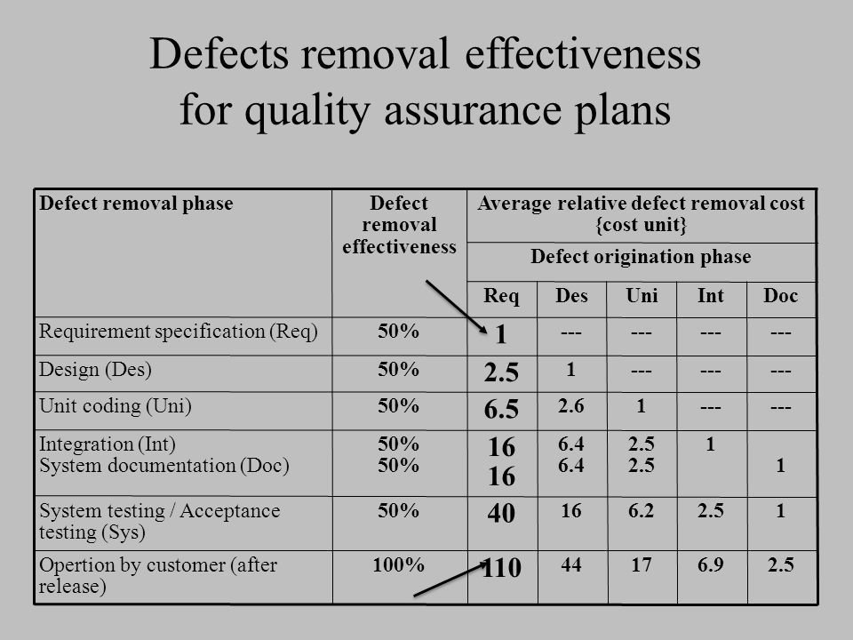

The Software Development Life Cycle model

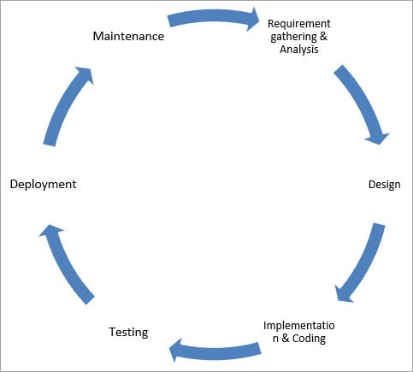

Requirements definition. For the functionality of the software system to
be developed, the customers must define their requirements. In many
cases the software system is part of a larger system. Information about
the other parts of the expanded system helps establish cooperation
between the teams and develop component interfaces.

Analysis. The main effort here is to analyze the requirements’ implica
tions to form the initial software system model.

Design. This stage involves the detailed definition of the outputs, inputs
and processing procedures, including data structures and databases, soft
ware structure, etc.

Coding. In this phase, the design is translated into a code. Coding
involves quality assurance activities such as inspection, unit tests and
integration tests.
System tests. System tests are performed once the coding phase is com
pleted. The main goal of testing is to uncover as many software errors as
possible so as to achieve an acceptable level of software quality once cor
rections have been completed. System tests are carried out by the
software developer before the software is supplied to the customer. In
many cases the customer performs independent software tests (“accept
ance tests”) to assure him or herself that the developer has fulfilled all the
commitments and that no unanticipated or faulty software reactions are
anticipated. It is quite common for a customer to ask the developer to
join him or her in performing joint system tests, a procedure that saves
the time and resources required for separate acceptance tests.

Installation and conversion. After the software system is approved, the
system is installed to serve as firmware, that is, as part of the information
system that represents a major component of the expanded system. If the
new information system is to replace an existing system, a software con
version process has to be initiated to make sure that the organization’s
activities continue uninterrupted during the conversion phase.

Regular operation and maintenance. Regular software operation begins
once installation and conversion have been completed. Throughout the
regular operation period, which usually lasts for several years or until a
new software generation appears on the scene, maintenance is needed.
Maintenance incorporates three types of services: corrective – repairing
software faults identified by the user during operation; adaptive – using
the existing software features to fulfill new requirements; and perfective
– adding new minor features to improve software performance.

The waterfall model
What is waterfall model?

The classical waterfall model which is also known as the linear-sequential life cycle model is an essential software development model which can be understandable from the structure itself. The model is straightforward yet idealistic. When this model was first introduced, it used to be very popular, but time, the new model has come up with a change in features and requirements and hence it is used decidedly less but still a popular one which everyone must know. All the old software has been developed based on this model's life cycle. It is a sequential model which segregates software development into different phases. Each phase is designed with some unique functionality and use. The model was pioneered in the year 1970 by Winston Royce.
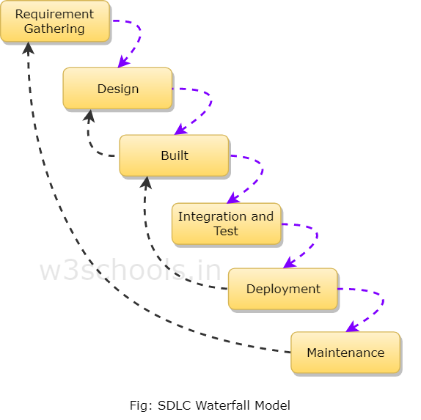

The prototyping model
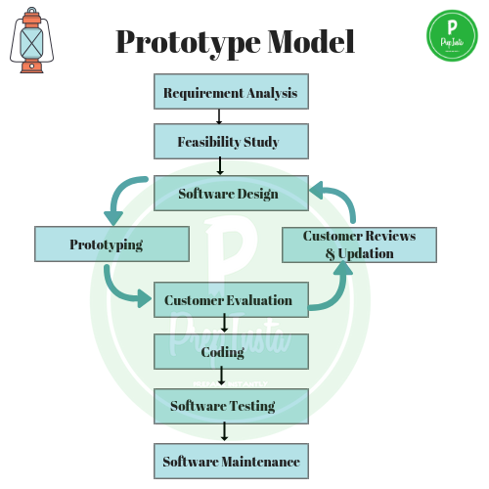

Replaces some of the parts of the SDLC with an
evolutionary and iterative process.
◆ Software prototypes are repeatedly provided to
customer for evaluation and feedback.
◆ Primarily iterate design and implementation.
◆ Development team provided requirements.
◆ Ultimately, the product reaches a satisfactory
completion.
◆ Then, the remainder of the process is carried out
in the context of another model, such as SDLC

This model is efficient
and effective mainly for
small- to medium-sized
software development
projects.

Prototyping versus SDLC methodology

◆ Advantages of prototyping:
◆ Shorter development process.
◆ Substantial savings of development resources (man-days).
◆ Better fit to customer requirements and reduced risk of project
failure.
◆ Easier and faster user comprehension of the new system.

The spiral model
The spiral model, as revised by Boehm (1988, 1998), offers an improved
methodology for overseeing large and more complex development projects
displaying higher prospects for failure, typical of many projects begun in the
last two decades. It combines an iterative model that introduces and empha
sizes risk analysis and customer participation into the major elements of
SDLC and prototyping methodologies.

According to the spiral model, software development is perceived to be an iterative process; at each iteration, the following
activities are performed

■ Planning
■ Risk analysis and resolution
■ Engineering activities according to the stage of the project: design, cod
ing, testing, installation and release
■ Customer evaluation, including comments, changes and additional
requirements, etc.

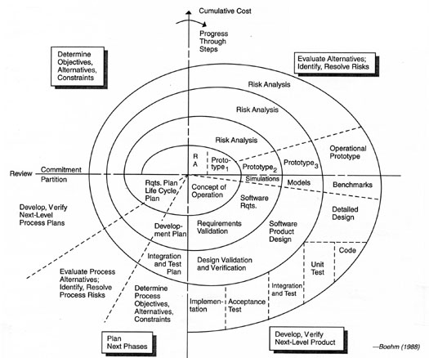

■ Customer’s specification of requirements, comments and change demands
■ Developer’s planning activities
■ Developer’s risk analysis and resolution
■ Developer’s design activities
■ Developer’s construction activities pertaining to coding, testing, installa
tion and release
■ Customer’s evaluation

The object-oriented model

The object-oriented model differs from the other models by its intensive
reuse of software components. This methodology is characterized by its easy
integration of existing software modules (called objects or components) into
newly developed software systems. A software component library serves this
purpose by supplying software components for reuse.

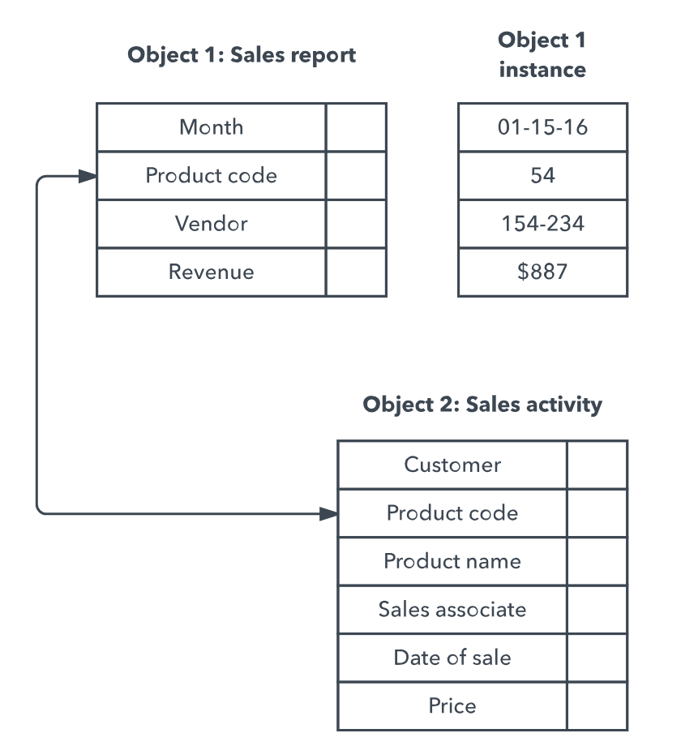

Advantage of object-oriented model

◆ Economy – The cost of integrating a reusable
software component is much lower than the cost of
developing new components.
◆ Shorter development time – The integration of
reusable software components reduces scheduling
pressures.
◆ Improved quality – Used software components are
expected to contain considerably fewer defects than
newly developed software components due to
detection of faults by former users.

The model

◆ POD = Phase Originated
Defects
◆ PD = Passed Defects (from
former phase or former quality
assurance activity)
◆ %FE - of filtering
effectiveness
◆ RD – Removed defects
◆ CDR – Cost of defect removal
◆ TRC – Total Removal Costs
FE
RD
CDR
TRC

Comparison of two plans
◆ The standard plan successfully removes 57.6% of the defects in requirements and design
compared to 90.2% in the comprehensive plan before coding begins.
◆ Results from more intensive defect-removal efforts.
◆ The comprehensive plan as a whole is much more economical than the standard plan as it saves
41% of the total resources investing in defect removal, compared with the standard plan
◆ Compared to the standard plan, the comprehensive plan makes a greater contribution to
customer satisfaction by drastically reducing the rate of defects detected during regular
operations: 6.9% to 2.6%

Ch8
Introduction
◆ The design document is key. It is checked repeatedly
in the development process.
◆ Typically, they are reviewed many times before getting a
stamp of approval to proceed with development.
◆ Unfortunately, we often don’t find our own errors and
thus we need others for reviews. Different stakeholders
with different viewpoints join in the review process.
◆ “A process or meeting during which a work product or set
of work products is presented to project personnel,
managers, users, customers, or other interested parties
for comment or approval.” -- IEEE
◆ Essential to detect/correct errors in these earlier work
products because the cost of errors downstream is very
expensive!!

Review objectives
Several objectives motivate reviews. The review’s direct objectives deal with
the current project, whereas its indirect objectives, more general in nature,
deal with the contribution of the review proper to the promotion of team
members’ professional knowledge and the improvement of the development
methodologies applied by the organization

Direct objectives
■ To detect analysis and design errors as well as subjects where corrections,
changes and completions are required with respect to the original
specifications and approved changes.
■ To identify new risks likely to affect completion of the project.
■ To locate deviations from templates and style procedures and conventions.
Correction of these deviations is expected to contribute to improved
communication and coordination resulting from greater uniformity of
methods and documentation style.
■ To approve the analysis or design product. Approval allows the team to
continue to the next development phase.

Indirect objectives
■ To provide an informal meeting place for exchange of professional
knowledge about development methods, tools and techniques.
■ To record analysis and design errors that will serve as a basis for future
corrective actions. The corrective actions are expected to improve
development methods by increasing effectiveness and quality, among other
product features

Participants in the review

◆ Review Leader
◆ External, but must have knowledge and experience in
development of the review type
◆ Seniority at least as high as the project leader.
◆ Good relationship with project leader and team, but NOT
be the project leader.
◆ Would impact objectivity, would miss things entirely!

◆ Review Team
◆ Needs to be from senior members of the team with other
senior members from other departments.
◆ Team size should be 3-5 members.
◆ Too large, and we have too much coordination.
◆ This is a time for serious business

Formal design reviews (DRs)
Formal design reviews, variously called “design reviews”, “DRs” and “for
mal technical reviews (FTR)”, differ from all other review instruments by
being the only reviews that are necessary for approval of the design product.
Without this approval, the development team cannot continue to the next
phase of the software development project. Formal design reviews may be
conducted at any development milestone requiring completion of an analy
sis or design document, whether that document is a requirement
specification or an installation plan.

Some common formal design reviews
DPR – Development Plan Review
SRSR – Software Requirement Specification Review
PDR – Preliminary Design Review
DDR – Detailed Design Review
DBDR – Data Base Design Review
TPR – Test Plan Review
STPR – Software Test Procedure Review
VDR – Version Description Review
OMR – Operator Manual Review
SMR – Support Manual Review
TRR – Test Readiness Review
PRR – Product Release Review
IPR – Installation Plan Rev

Preparations for the Design Review

◆ Participants in the review include the
◆ Review leader, review team and development team
◆ Review Leader:
◆ appoint team members
◆ establishes schedule
◆ distribute design documents, and more
◆ Review Team preparation:
◆ review document; list comments PRIOR to review session
◆ For large design docs, leader may assign parts to individuals
◆ Complete a checklist
◆ Development Team preparations:
◆ Prepare a short presentation of the document
◆ Focus on main issues rather than describing the process
◆ This assumes review team has read document and is familiar with.

Design review report
following the review.
◆ Important to perform corrections early and minimize
delays to project schedule.
◆ Report contains:
◆ Summary of review discussions
◆ Decision about project continuation
◆ Full list of action items – corrections, changes, additions the
project team must perform. For each item, anticipated
completion date and responsible person is listed.
◆ Name of review team member assigned for follow up.

Follow up process

◆ The ‘follow-up person’ may be the review team
leader him/herself
◆ Required to verify each action item fixed as
condition for allowing project to continue to next
phase.
◆ Follow up must be fully documented to enable
clarification of the corrections in the future, if any.

Problems
◆ Sometimes entire parts of DR are often worthless due to
◆ inadequately prepared review team, or
◆ intentional evasion of a thorough review.
◆ Tipoff:
◆ Very short report – limited to documented approval of the
design and listing few, if any, defects
◆ Short report approving continuation to next project phase in full -
listing several minor defects but no action items.
◆ A report listing several action items of varied severity but no
indication of follow-up (no correction schedule, no documented activities, …)

The participants in a DR

All DRs are conducted by a review leader and a review team. The choice of
appropriate participants is of special importance because of their power to
approve or disapprove a design product.

The review leader
Because the appointment of an appropriate review leader is a major factor
affecting the DR’s success, certain characteristics are to be looked for in a
candidate for this position:

■ Knowledge and experience in development of projects of the type reviewed.
Preliminary acquaintance with the current project is not necessary.
■ Seniority at a level similar to if not higher than that of the project leader.
■ A good relationship with the project leader and his team.
■ A position external to the project team.

Thus, appropriate candidates for review team leadership include the devel
opment department’s manager, the chief software engineer, the leader of
another project, the head of the software quality assurance unit and, in cer
tain circumstances, the customer’s chief software engineer.
p
Implementation tip

In some cases, the project leader is appointed as the review leader, the main
justification for this decision being his or her superior knowledge of the
project’s material. In most cases, this choice proves to be undesirable
professionally. A project leader who serves as the review team leader tends,
whether intentionally or nor, to limit the scope of the review and avoid incisive
criticism. Review team members tend to be chosen accordingly. Appointments
of this type usually undermine the purpose for the review and only delay
confrontation with problems to a later, more sensitive date

Pressman's guidelines for a successful DR
Design Review Infrastructure
◆ Develop checklists for common types of design documents.
◆ Train senior professionals to serve as a reservoir for Design Review
teams.
◆ Periodically analyze past Design Review effectiveness.
◆ Schedule the Design Reviews as part of the project plan

The Design Review Team
◆ Review teams size should be limited, with 3–5 members being the
optimum.

Post-Review Activities
◆ Prepare the review report, including the action items
◆ Establish follow-up to ensure the satisfactory performance of all the
list of action items

Ch8 Reviews
◆ Review objectives
◆ Formal design reviews (DRs)
◆ Participants
◆ Preparations
◆ Sessions
◆ Post-review activities
◆ Peer reviews (inspections and walkthroughs)
◆ Participants
◆ Preparations
◆ Sessions
◆ Post-review activities
◆ Peer review coverage
◆ Comparison of peer reviews methods

Inspection and walkthrough

◆ Mainly differs on the level of formality, inspection is more
formal and provides more contribute
◆ Inspection emphasizes the objective of corrective action,
while walkthrough’s comments on the document
reviewed. Inspection’s findings are incorporated into
efforts to improve development methods itself
◆ Inspection infrastructures
◆ Checklists for design document, coding language and tool
◆ Defect frequency tables, based on past findings, to direct
inspectors to potential “defect concentration areas”
◆ Training of competent professionals in inspection process issues
◆ Periodic analysis of the effectiveness of past inspections to
improve the inspection methodology
◆ Schedule
Recommended sections
Sections recommended for inclusion
◆ Sections of complicated logic
◆ Critical sections, where defects severely damage essential system
capability
◆ Sections dealing with new environments
◆ Sections designed by new or inexperienced team members

Sections recommended for omission
◆“Straightforward” sections (no complications)
◆Sections of a type already reviewed by the team in similar past
projects
◆Sections that, if faulty, are not expected to effect functionality
◆Reused design and code
◆Repeated parts of the design and code

Peer review sessions
◆ Procedurally, presenter reads document section and may add
an explanation.
◆ Participants may offer comments on docs
◆ Restrict discussion to identification of errors – no solutions.
◆ Inspection scribe will add estimated severity of each defect, a
factor to be used in the statistical analysis of defects found and
for the foundation of preventive / corrective actions.
◆ Presenter in walkthrough provides an overview
◆ Walkthrough Scribe records each error (location, description,
type) – incorrect, missing, etc.

Post review sessions
◆ For inspections – comprehensive report
◆ Report summarizes inspection findings and resources invested in the
inspections…
◆ Report serves as inputs for analysis aimed at inspection process
improvement and corrective actions that go beyond the specific document
or project.
◆ For walkthroughs – copies of the error documentation should be
provided to the development team and the session participants.
◆ Inspection does not end with a review session or distribution of
reports
◆ Post inspection activities are conducted to attest to
◆ Prompt, effective correction/reworking of all errors
◆ Transmission of the inspection reports to controlling authority for

The Efficiency of Peer Reviews
◆ Metrics applied to estimate the effectiveness of
peer reviews
◆ Peer review detection efficiency (average hours worked per
defect detected)
◆ Peer review defect detection density (average number of
defects detected per page of the design document)
◆ Internal peer review effectiveness (percentage of defects
detected by peer review as a percentage of total defects
detected by the developer

Code inspection effectiveness at Fujitso

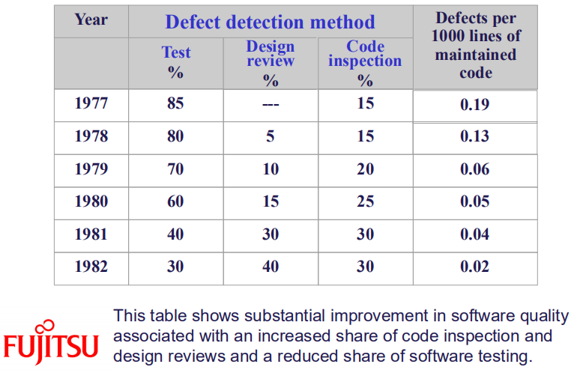

Comparison of reviews

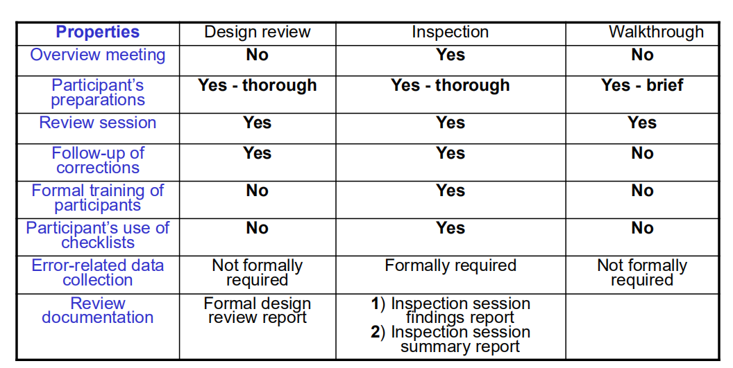

Expert Opinions
◆ Most experts support quality evaluation by introducing
additional capabilities for the internal review staff.
◆ The organization’s internal quality assurance activities
are thereby reinforced.
◆ Experts suggest participation of an expert or his/her
participation as an external review member if the
following circumstances apply:
◆ Insufficient in-house professional capabilities in a specialized area.
◆ Temporary lack of in-house professionals for review team.
◆ Indecisiveness caused by major disagreements among the
organization’s senior professionals.

Software testing strategies

Software testing (or “testing”) was the first software quality assurance tool
applied to control the software product’s quality before its shipment or
installation at the customer’s premises. At first, testing was confined to the
final stage of development, after the entire package had been completed.
Later, as the importance of early detection of software defects penetrated
quality assurance concepts, SQA professionals were encouraged to extend
testing to the partial in-process products of coding, which led to software
module (unit) testing and integration testing. Common to all testing activities is their application through the direct
running of code, free of review of development documents. Some authors
tend to broaden the scope of testing even further and consider all software
life cycle quality assurance activities as types of testing activities. In this
book, we limit the scope of testing to quality assurance activities performed
by running code.
Software testing is undoubtedly the largest consumer of software quality
assurance resources. In a survey performed in November 1994, Perry (1995)
found that on average, 24% of the project development budget was allocat
ed to testing. In addition, 32% of the project management budget was slated
for testing activities. With respect to time resources, an average of 27% of
project time was schedule for testing. The survey’s participants also indicated
that they planned to allocate substantially more time (45% on average) to
testing but that the pressures typically arising toward the close of projects gen
erally forced project managers to reduce the testing time scheduled.
Testing is certainly not the only type of SQA tool applied to software
code. Additional tools are code inspections and code walkthroughs, methods
implemented on code printout without actually running the program. These
procedures, which are similar to those applied in design inspection and walk
throughs, yield good results in identifying code defects. Nevertheless, these
tools, because they are based solely on the review of documents, can never
replace testing, which examines the software product’s functionality in the
form actually used by the customer. For further discussion of these software
quality tools see Chapter 8.
This chapter is dedicated to testing strategies and test classifications.
After defining testing and its objectives, the chapter discusses testing strate
gies and classifies them according to requirement types.
Additional material on testing can be found in the numerous papers and
books dealing with software testing. A sample of these sources are the books
by Beizer (1984), Perry (1995), Kit (1995), Jorgensen (1995), Kaner et al.
(1999), Rubin (1994) and Perry and Rice (1997). Another valuable source of
material on software testing can be found in the software engineering and
software quality assurance literature, such as Pressman (2000), Sommerville
(2001) and Hamlet and Maybee (2001), to mention but a few.

After completing this chapter, you will be able to:
■ Explain testing objectives.
■ Discuss the differences between the various testing strategies, their advan
tages and disadvantages.
■ Describe the concepts of black box testing and white box testing as well
as discuss their advantages and disadvantages.
■ Define path coverage versus line coverage.
■ Describe the various types of black box tests.

Definition and objectives
The variety of definitions for software testing found in the literature reveals
the varied scope of the process, which may be constricted or broadened.
Quite broad in scope is Myers’ (1979, Chapter 10) classic definition:
“Testing is the process of executing a program with intention of
finding errors.”
According to this rather inclusive definition, activities ranging from code
checks performed by a team leader to trial runs of the software performed
by a colleague, as well as tests carried out by a testing unit, can all be con
sidered testing activities.
Much more formal and controlled are the two definitions for testing sug
gested by IEEE Std 610.12 (IEEE, 1990):
“(1) The process of operating a system or component under specified con
ditions, observing or recording the results, and making an evaluation of
some aspect of the system or component. (2) The process of analyzing a
software item to detect the differences between existing and required con
ditions (that is, bugs) and to evaluate the features of the software item.”
It should be noted that according to the second definition, running the pro
gram as part of the testing process is not required.
The definition applied in this book stresses the formal operative charac
teristics of testing

Software tests – definition
Software testing is a formal process carried out by a specialized testing team
in which a software unit, several integrated software units or an entire
software package are examined by running the programs on a computer. All
the associated tests are performed according to approved test procedures on
approved test cases.

The words and phrases stressed in the definition allow us to compare the
key characteristics of software testing with those of other software quality
assurance life cycle tools:

Formal – Software test plans are part of the project’s development and
quality plans, scheduled in advance and often a central item in the devel
opment agreement signed between the customer and the developer. In other
words, ad hoc examination of software by a colleague or regular checks by
the programming team leader cannot be considered software tests.
Specialized testing team – An independent team or external consultants 181
who specialize in testing are assigned to perform these tasks mainly in
order to eliminate bias and to guarantee effective testing by trained pro
fessionals. In addition, it is generally accepted that tests performed by the
developers themselves will yield poor results, as those individuals who
developed the original product will find it difficult to reveal errors that
they were unable to identify earlier. Still, unit tests continue to be per
formed by developers in many organizations.

Running the programs – Any form of quality assurance activity that does
not involve running the software, for example code inspection, cannot be
considered as a test.

Approved test procedures – The testing process performed according to a
test plan and testing procedures that have been approved as conforming
to the SQA procedures adopted by the developing organization.

Approved test cases – The test cases to be examined are defined in full by
the test plan. No omissions or additions are expected to occur during test
ing. In other words, once the process has begun, the tester is not allowed
to exercise discretion by omitting a test case he or she considers redun
dant or by adding a new test case, promising though it may be.

Software testing objectives
Direct objectives
■ To identify and reveal as many errors as possible in the tested software.
■ To bring the tested software, after correction of the identified errors and
retesting, to an acceptable level of quality.
■ To perform the required tests efficiently and effectively, within budgetary
and scheduling limitations.

Indirect objective
■ To compile a record of software errors for use in error prevention (by
corrective and preventive actions).

Software testing strategies
Although test methodologies may vary, often greatly, these are applied with
in the framework of two basic testing strategies:
■ To test the software in its entirety, once the completed package is avail
able; otherwise known as “big bang testing”.
■ To test the software piecemeal, in modules, as they are completed (unit
tests); then to test groups of tested modules integrated with newly com
pleted modules (integration tests). This process continues until all the
package modules have been tested. Once this phase is completed, the
entire package is tested as a whole (system test). This testing strategy is
usually termed “incremental testing”

Furthermore, incremental testing is also performed according to two basic
strategies: bottom-up and top-down. Both incremental testing strategies
assume that the software package is constructed of a hierarchy of software
modules. In top-down testing, the first module tested is the main module,
the highest level module in the software structure; the last modules to be
tested are the lowest level modules. In bottom-up testing, the order of test
ing is reversed: the lowest level modules are tested first, with the main
module tested last.

■ Stage 1: Unit tests of modules 1 to 7.
■ Stage 2: Integration test A of modules 1 and 2, developed and tested in
stage 1, and integrated with module 8, developed in the current stage.
■ Stage 3: Two separate integration tests, B, on modules 3, 4, 5 and 8, inte
grated with module 9, and C, for modules 6 and 7, integrated with
module 10.
■ Stage 4: System test is performed after B and C have been integrated with
module 11, developed in the current stage.

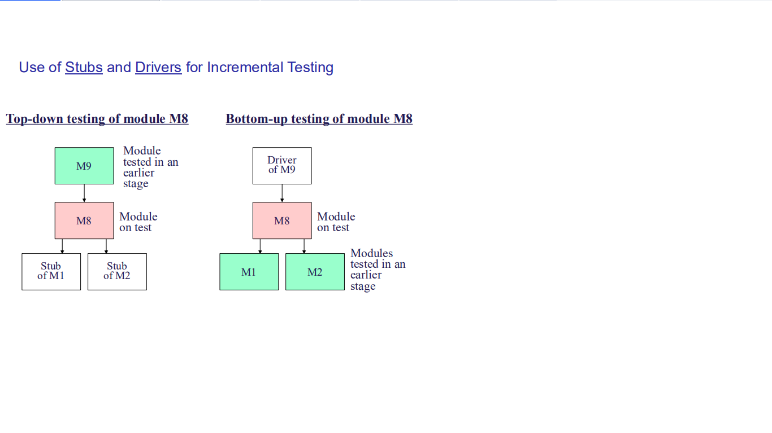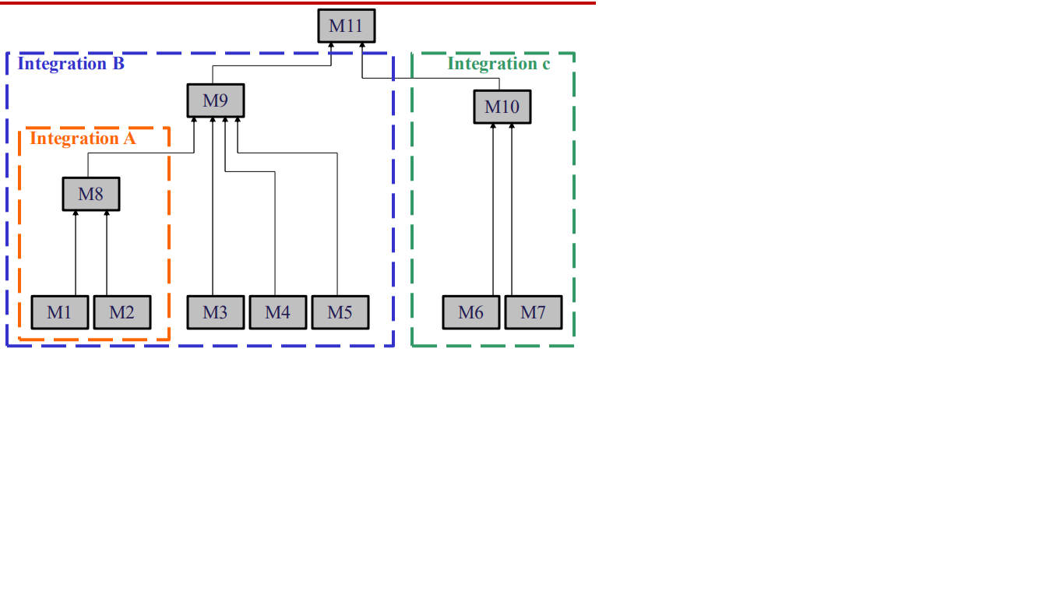

Software test classifications
Software tests may be classified according to the testing concept or to the
requirements classification in effect

Classification according to testing concept
There is an ongoing debate over whether testing the functionality of software
solely according to its outputs is sufficient to achieve an acceptable level of
quality. Some claim that the internal structure of the software and the calcu
lations (i.e., the underlying mathematical structure, also known as the
software “mechanism”) should be included for satisfactory testing. Based on
these two opposing concepts or approaches to software quality, two testing
classes have been developed:

Black box (functionality) testing. Identifies bugs only according to soft
ware malfunctioning as they are revealed in its erroneous outputs. In
cases that the outputs are found to be correct, black box testing disre
gards the internal path of calculations and processing performed.
■ White box (structural) testing. Examines internal calculation paths in
order to identify bugs. Although the term “white” is meant to emphasize
the contrast between this method and black box testing, the method’s
other name – “glass box testing” – better expresses its basic characteris
tic, that of investigating the correctness of code structure.

Black box and white box testing – IEEE definitions

Black box testing:
(1) Testing that ignores the internal mechanism of a system or component and
focuses solely on the outputs generated in response to selected inputs
and execution conditions.
(2) Testing conducted to evaluate the compliance of a system or component
with specified functional requirements.

White box testing

Realization of the white box testing concept requires verification of every
program statement and comment. As shown in Table 9.2, white box testing
enables performance of data processing and calculations correctness tests,
software qualification tests, maintainability tests and reusability tests.
In order to perform data processing and calculation correctness tests
(“white box correctness test”), every computational operation in the
sequence of operations created by each test case (“path”) must be examined.
This type of verification allows us to decide whether the processing opera
tions and their sequences were programmed correctly for the path in

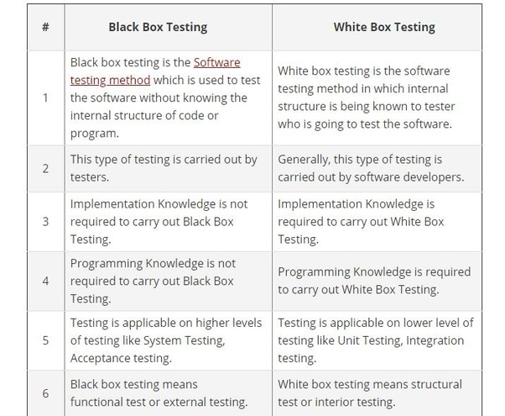

White box testing: more detail
Data processing and calculation correctness.
◆ Enter ‘Coverage’ issues.
◆ Major topics for many theses….
◆ Note: just cannot possibly cover all paths. As
mathematically there are infinite number of paths.
◆ So, we look at two categories:
◆ Path coverage
◆ Line coverage
Path vs. Line coverage
Path coverage
◆ Path coverage is measured as percentage of all
possible program paths included in planned testing.
Line coverage
◆ Line coverage is measured by the percentage of
program code lines included in planned testing.
◆ Tons of material in the literature on path, line, and
branch coverage!!

Path coverage
◆ Note: every path (if-then-else; do-while, etc.) is a
‘different’ path with different values.
◆ We’d like to tests all paths.
◆ Total number of paths is countably infinite.
◆ If one calculates the number of paths in a non-trivial
routine, the number of test cases required is huge and
very impractical.
◆ Except for some special security applications, we will use
alternative strategies: line coverage.
Line coverage
◆ Desirable to test every line of code at least once during testing.
◆ Define degree of coverage as the number of lines executed
over the number of executable lines available.
◆ Let’s consider a program flow chart to make our point.
◆ A diamond is a decision;
◆ A rectangle consists of imperatives and connections to conditional
statements.
◆ Edges represent sequences of sections
◆ Let’s consider a program flow graph, with sections of code to

Tree Class – Top down
class Tree
{
private Node root; // only data field in Tree; but key!
public void find (int key)
{
// stub: not showing details of this method here
}// end find()
public void insert (int id, double dd)
{
// stub; placeholder
}// end insert()
pubic void delete (int id)
{
// stub
}// end delete()
} // end class Tree.

In main() somewhere:
Tree theTree = new Tree();
 theTree.find();// main hunks of functionality
 theTree.insert();
 theTree.display();
 // program runs in its entirety each time.

class Tree
{
private Node root; // only data field in Tree; but key!
public void find (int key)
{
// stub: not showing details of this method here
System.out.println ( “Got into find()” );
}// end find()
public void insert (int id, double dd)
{
// stub; placeholder
System.out.println ( “Got into insert()” );
}// end insert()
pubic void delete (int id)
{
// stub
System.out.println (“ Got into delete routine () “ );
}// end delete()
} // end class Tree

public Node find (int key)
{ // assumes non-empty tree
Node current = root; // start at root
while (current.iData != key) // if no match
{
if (key < current.iData)
current = current.leftChild;
// recall: current = current.next??
else
current = current.rightChild;
If (current == null)
return null; // not found; boundary Condition
} // end while
return current; // returns reference to node
} // end find()
Fill in code incrementally
class Tree
{
private Node root;
// only data field inTree; but key!
public void find (int key)
{
Node current = root;
// start at root
while (current.iData != key)
// if no match
{
if (key < current.iData)
current = current.leftChild;
else
current = current.rightChild;
If (current == null)
return null;
// not found; boundary condition
} // end while
return current;
// returns reference to node
} // end find()

public void insert (int id, double dd)
{
// stub; placeholder
System.out.println ( “Got into insert()” );
}// end insert()
pubic void delete (int id)
{
// stub
System.out.println(“Got into delete routine”);
}// end delete()
} // end class Tree.

Tree Class – Bottom up
◆ For bottom up, you must simulate data passed to a lower
level module from above.
◆ Use dummy data, parameters and returns
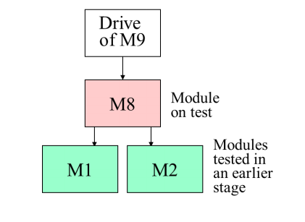

Comparison: Bottom-up vs. Top-down

Top-down
◆ It demonstrates the entire program functions shortly after
activation of the upper level modules are completed
◆ Can show early analysis and design flaws
◆ It often requires complicated programming and relative difficulty of
analyzing the results of tests.
◆ Supports top down programming, top down testing
◆ Easy to add functionality via stubs and drivers
Bottom-up
◆ Relative ease of its performance
◆ Too late to observe the program as a whole
◆ Pieces may not fit. Structure may be off.
◆ Awkward to pass dummy data and to accept returned data…

Big Bang vs. Incremental
◆ Big Bang testing, in general, not a good approach, unless program
is very small and not terribly complicated.
◆ Simply way, but too much code/functionality to evaluate at one time.
◆ Difficult to identify errors and where they are located.
◆ Incremental testing provides a number of advantages
◆ Test on usually small hunks of code, like unit or integration tests.
◆ Easier to identify errors than with whole project
◆ Correction is much simpler and requires far fewer resources too
◆ Find errors much earlier in process.
◆ Prevents migration of errors into later, more complex stages.
◆ Do have overhead of developing drivers and stubs and drivers for integration
testing.
◆ Can carry out many testing operations on the same program vice only a single
testing operation.
◆ Best: generally incremental approach is preferred despite its

Taxi service fee
Taxi fares for one-time passengers are calculated as
follows:
1.Minimal fare: $2. This fare covers the distance traveled
up to 1000 yards and waiting time (stopping for traffic
lights or traffic jams, etc.) of up to 3 minutes.
2.For every additional 250 yards or part of it: 25 cents.
3.For every additional 2 minutes of stopping or waiting or
part thereof: 20 cents.
4.One suitcase: 0 change; each additional suitcase: $1.
5.Night supplement: 25%, effective for journeys between
9pm - 6am (subject to the starting time).
Regular clients are entitled to a 10% discount and are not
charged the night supplement.

Flow chart - Path Coverage
✓In planning, a flowchart
were developed.
✓Note: five decisions enter
into planning for path
testing…
✓Twenty-four different
paths may be executed to
have full coverage.
✓Means we need to prepare
24 different test cases.
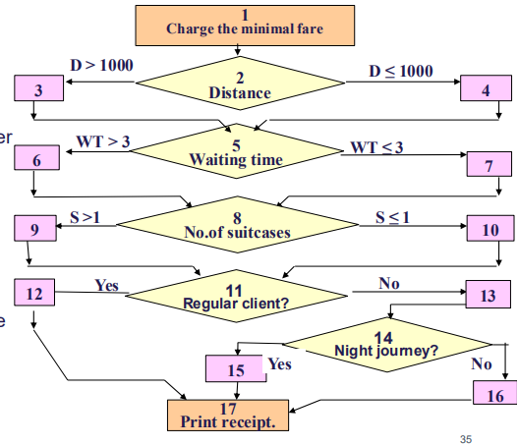

Flow graph - line coverage
But, if we only insist on ‘line coverage’,
we can get full line coverage with three tests:
1 2 3 5 6 8 9 11 12 17
1 2 4 5 7 8 10 11 13 14 15 17
1 2 4 5 7 8 10 11 13 14 16 17
So, we have three test cases
compared with 24!
Savings goes up exponentially
with programs of greater
complexity.
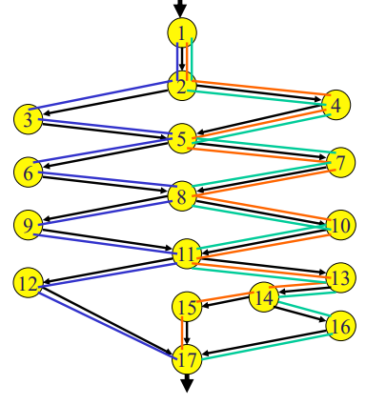
McCabe’s complexity metrics give an
upper limit to the number of test cases
needed for full line coverage.
McCabe used graph theory to arrive
at a minimum number of tests to
ensure full line coverage based
on a program flow graph.
Any path must have at least one
edge not in another path.
Number of paths has been used to
indicate overall program complexity

Taxi service fee - incremental

float fee(dist, waitTm, caseNo, boardingTm, vipNo);
float fee_distance(dist);
float fee_waiting(waitTm);
float fee_suitcase(caseNo);
float fee_night(boardingTm);
float fee_vip(vipNo);

Create stubs and drivers

Besides functionality
◆ Does the code fulfill the code structure instructions and procedures,
such as module size, application of reused code, etc.?
◆ Does the coding style fulfill coding style procedures?
◆ Do the internal program documentation and “help” sections (e.g.,
comments) fulfill coding style procedures?
◆ Use code auditors
◆ Determining whether the packaging and documentation of the
programs and modules listed for reuse conform to the standards and
procedures demanded for inclusion in the reusable software library.
◆ Reusability testing is actually one of the tools supporting the growth of
software reuse.
Software qualification testing
Software reusability testing
Equivalence classes for output correctness
◆ Bottom line here: by using ECs, far fewer test
cases needed than might otherwise be needed
◆ Test cases are based on the specifications not
on code
◆ Better results are obtained in testing boundary
values of ECs as well.
◆ Very important to test boundaries. Rich source
of very common errors.

Equivalence classes for output correctness
◆ Boundary class testing example
◆ Sequentially read a file:
◆ Boundary issues:
◆ Can’t open the file
◆ File is empty (no records)
◆ Read beyond end of file
◆ File has one record
◆ Standard EC test here: once you process two records, you are
likely good to go.
◆ Stack:
◆ Stack empty; stack full. These are the boundary conditions.
◆ Other processing - normal
◆ Always, test the boundaries!!!

Test cases and boundary values
◆ Formally, one test case per equivalence class should be
enough.
◆ If have range of values, border values are very error
prone.
◆ Example: range of acceptable values: 1-10.
◆ Midrange test (no problem) any number 2-9;
◆ Boundary value tests: test 1 and test 10.
◆ Test for mid range, lower and upper bound values!!

Equivalence class partitioning

◆ A black box method aimed at increasing the efficiency of
testing and, at the same time, improving coverage of
potential error conditions.
◆ An equivalence class (EC) is a set of input variable
values that produce the same output results or that are
processed identically.
◆ An EC with only valid states is defined as a valid EC,
whereas an EC that contains only invalid states is
defined as the invalid EC.
◆ For an acceptable range of input integers is 1-10, we need at
least one valid EC case with a value in the range 1-10.
◆ Boundaries: 1 and 10
◆ Invalid EC classes might be EC with values < 1, > 10, and
negative numbers, (char, floating number ??)
◆ Definition of test cases is done separately for the valid
and invalid ECs.
◆ In defining a test case for the valid ECs, we try to cover as many
as possible “new” ECs in that same test case.
◆ In defining invalid ECs, assign one test case to each “new”
invalid EC.
◆ Run separately. A test case with more than one invalid
EC may not allow the tester to distinguish between the
program’s separate reactions to each of the invalid ECs.
◆ Test cases are added as long as there are uncovered
ECs.

Example – swimming center

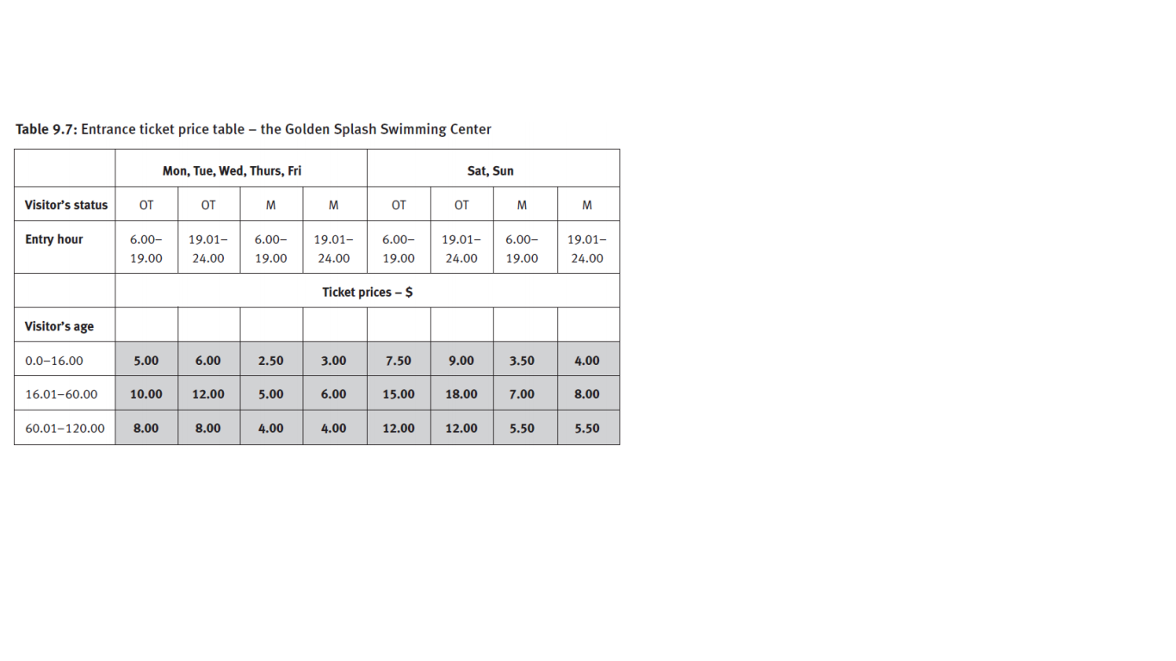

Operation factor testing cases
Documentation tests
◆ Erroneous user manuals and operators manuals (Do not forget!)
◆ Functional Descriptions
◆ Overview describes system. Useful for many purposes
◆ Installation Manual
◆ How to install and interface with equipment; contains customization
instructions
◆ User Manual
◆ How to use various functions, recovery instructions; documented help…
◆ Program Maintenance Manual
◆ Bug corrections, changes, program structure, some algorithms…
Availability (reaction time tests)
◆ Critically important for online applications.
◆ Response time
◆ Critical for real time systems
◆
Reliability
◆ Difficult to test
◆ Need to run under various and regular workload conditions
◆ Often simulated environment and loads
Stress tests – load tests
◆ Load tests are related to the functional performance under max
load conditions
◆ E.g. Hits per minute, number of simultaneous users.
◆ Usually simulate more load than specifications cite.
Stress tests – durability tests
◆ Extreme operating conditions, temperature, humidity, rough
conditions, think aircraft instrumentation and guidance…sudden
electrical ‘jumps’ communications cutoff (battery backup? …)
We are not going
Usability tests
◆ Training and Operational usability tests
◆ Test the operator’s productivity in using or trying to use the
application. Observation and his/her productivity. Can be
quantitative and qualitative.
Maintainability tests
◆ Remember: More than 60% of a system’s operational time is
usually done in a maintenance mode!
◆ Other figures suggest higher rates!
Overall manuals should include one that
addresses: system structure, programmer
maintenance and an operator’s manual.
Advantages and disadvantages
Advantages:
◆ Allows us to carry out the majority of testing classes, most of which
can be implemented solely by black box tests, i.e. load tests and
availability tests.
◆ For testing classes that can be carried out by both white and black
box tests, black box testing requires fewer resources.
Disadvantages:
◆ Possibility that coincidental aggregation of several errors will
produce the correct response for a test case, and prevent error
detection.
◆ Absence of control of line coverage. There is no easy way to
specify the parameters of the test cases required to improve
coverage.
◆ Impossibility of testing the quality of coding and its strict adherence
to the coding standards.

Software testing - implementation
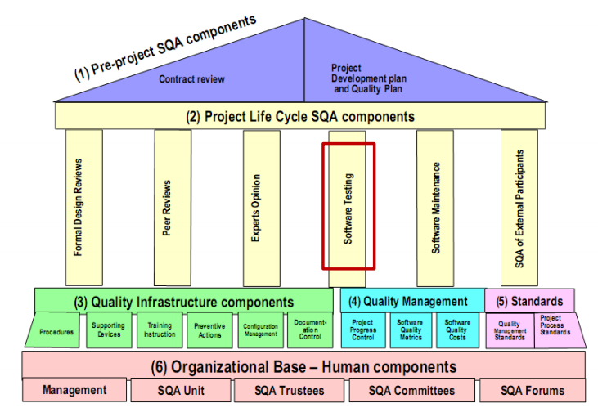

The main issues to be raised with respect to testing implementation are test
effectiveness and efficiency. In other words, constant efforts are to be direct
ed to reduction of the percentage of undetected errors remaining in the
software or system tested on the one hand, and to performance of those tests
with fewer resources on the other.
Despite the vast resources invested in defect identification, it is com
monly accepted that software free of defects is still an unrealizable task. This
situation has inspired testing professionals to stress the issues of effectiveness
and efficiency at every opportunity. The two main routes taken toward
improvement involve upgrading the effectiveness of the test cases applied
during testing, and development of automatic software testing.
The processes of designing, planning and carrying out tests at the vari
ous levels – unit tests, integration test and system test – are discussed in the
first section of this chapter. An improved test case file exhibits fewer repetitions of test cases cover
ing the same situation and covers the vast space of possible software
implementations more thoroughly and accurately. Accordingly, improve
ments in this area are expected to improve test efficiency by reducing the
total number of required test cases and, at the same time, increasing test
Effectiveness. As to the second improvement route, we are gradually realizing the
potential of automated computerized testing. A discussion of this subject is
presented in Section. An additional informal route for error detection of the software is based
on the contribution of future users to its quality through alpha and beta sites.
This option is discussed

Valuable sources for additional material on test implementation can be
found in books dealing with software testing, such as Perry (1995), Kit
(1995), Kaner et al. (1999) and Perry and Rice (1997). Other sources are
books on software engineering and software quality assurance such as
Pressman (2000) and Sommerville (2001), as are standards such as ISO/IEC
9000-3 (ISO/IEC, 2001), IEEE Std 829 (IEEE, 1998a), IEEE Std 1012 (IEEE,
1998b) and IEEE Std 12207 (IEEE, 1996, 1997a, 1997b), to cite some of the
major documents in this category.
After completing this chapter, you will be able to:
■ Describe the process of planning and designing tests.
■ Discuss the sources for test cases, with their advantages and disadvantages.
■ List the main types of automated software tests.
■ Discuss the advantages and disadvantages of automated computerized
testing as compared to manual testing.
■ Explain alpha and beta site test implementation and discuss their advan
tages and disadvantages

The testing process
Planning, design and performance of testing are carried out throughout the
software development process. These activities are divided in phases, begin
ning in the design stage and ending when the software is installed at the
customer’s site. The testing process is illustrated

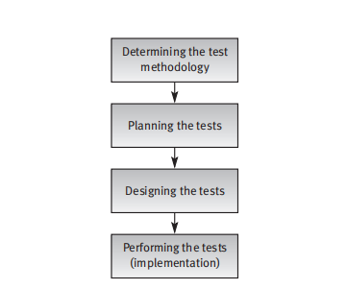

The main issues that testing methodology has to contend with are:
■ The appropriate required software quality standard
■ The software testing strategy.
Decisions about these two issues are fundamental and must be made before
planning begins.

Determining the appropriate software quality standard
The level of quality standard selected for a project depends mainly on the
characteristics of the software’s application.

■ Example 1: A software package for a hospital patient bed monitor
requires the highest software quality standard considering the possibly
severe consequences of software failure.
■ Example 2: A package developed for handling feedback information for
an organization’s internal employee training program could make do
with a medium-level software quality standard, assuming that the cost of
failure is relatively low (or much lower than that of Example 1).
■ Example 3: A software package has been developed for sale to a broad
range of organizations. The sales prospects justify higher quality stan
dards than would a custom-made software package having similar
characteristics yet developed to serve a single customer

These examples illustrate the main criterion to be applied when choosing the
software quality standard: the evaluation of the nature and magnitude of
expected damages in case of system failure. These damages may affect the
customers and users on one hand, and the developer on the other. In gener
al, the higher the expected level of damage resulting from failure, the higher
the appropriate standard of software quality.

Classification of software failure damage
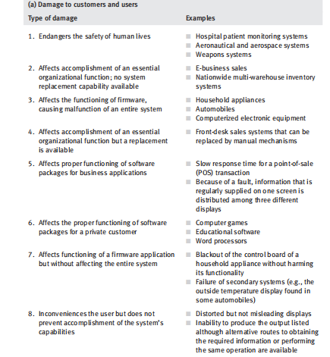
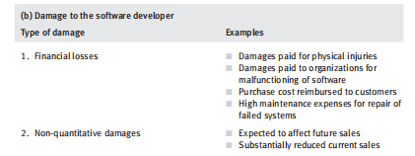

Determining the software testing strategy
The issues that have to be decided include:
■ The testing strategy: should a big bang or incremental testing strategy be
adopted? If incremental testing is preferable, should testing be performed
bottom-up or top-down?
■ Which parts of the testing plan should be performed according to the
white box testing model?
■ Which parts of the testing plan should be performed according to the
automated testing model?

Planning the tests
The tests to be planned include:
■ Unit tests
■ Integration tests
■ System tests.

While unit tests deal with small units of software or modules, integration
tests deal with several units that combine into a subsystem. System tests refer
to the entire software package/system.
It is incumbent upon planners to consider the following issues before ini
tiating a specific test plan:

What to test?
■ Which sources to use for test cases?
■ Who is to perform the tests?
■ Where to perform the tests?
■ When to terminate the tests?
These five issues will be discussed in this section. The last subject of the sec
tion will be devoted to documentation.

What to test?
A straightforward approach to perfect testing would recommend a full and
comprehensive software test plan that requires performing unit tests for all
the individual units, integration tests for all the unit integrations, and a sys
tem test to test the software package as a whole. Implementing this
“straightforward” plan ensures top quality software but requires the invest
ment of vast resources and an extended timetable.
Relatedly, certain questions will undoubtedly arise with respect to com
mon situations that pertain to the benefits of such an approach. For instance:
■ Is it justified to perform unit tests for a module composed of 98% reused
software?
■ Is a unit test mandatory for a simple module that represents the 12th ver
sion of a basic module repeatedly applied by the development team over
the last three years?

Only in rare cases it is justified to test “everything”. Usually, the feasibility of
testing “everything” is highly limited. Apart from performance of the list of
tests specified in the contract or required by the developer’s procedures (e.g.
load tests for the system as a whole), several considerations order our prefer
ences for the tests to be applied. The factors to be decided revolve around:
■ Which modules should be unit tested
■ Which integrations should be tested
■ The priorities determining allocation of testing resources to the individual
software system applications. As a result, low-priority applications are test
ed by only some types of tests or not included in the system test at all.
In determining what is to be included and what excluded from the system
tests, the unit and integration tests already planned should be considered.
For the software quality of applications and modules not covered by the
unit, integration and system tests, we rely on the code checks done by the
programmer and his team leader and on code inspections and walkthroughs
initiated by the development team.

Rating units, integrations and applications
The methods for rating units (modules), integrations and applications to
determine their priority in the testing plan are based on two factors:
■ Factor A: Damage severity level. The severity of results in case the module
or application fails. Table 10.1 can serve as a guideline to estimate severity.
■ Factor B: Software risk level. The level of risk represents the probability
of failure. In order to determine the risk level of a module, unit, integra
tion or application, the issues affecting risk require examination. These
issues can be classified as module/application issues and programmer
issues

Agenda

◆ First:
◆ Describe the process of planning and designing tests
◆ Discuss the sources for test cases, with their
advantages and disadvantages
◆ Next:
◆ List the main types of automated software tests
◆ Discuss the advantages and disadvantages of
automated computerized testing as compared to
manual testing
◆ Explain alpha and beta site test implementation and

The Testing Process
◆ Testing is done throughout the development
process.
◆ Testing is divided into phases beginning in the
design phase and ending at the customer’s site.
◆ The two fundamental decisions that must be
made before planning for testing can occur are:
◆ What is the required software quality standard
◆ What is the software testing strategy.
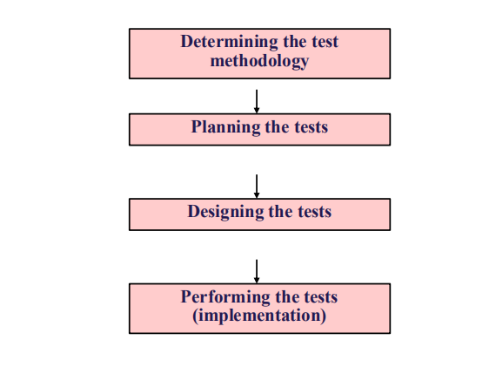
Software quality standard
◆ Different standards are required for different software
applications.
◆ Safety-critical software or aircraft instrumentation - critical
◆ In other cases, a medium-level quality would be sufficient
◆ So, the expected damage resulting from failed software
impacts standard of software quality.
◆ Damage to customers and users
◆ Damage to developers

Damages to customers and users
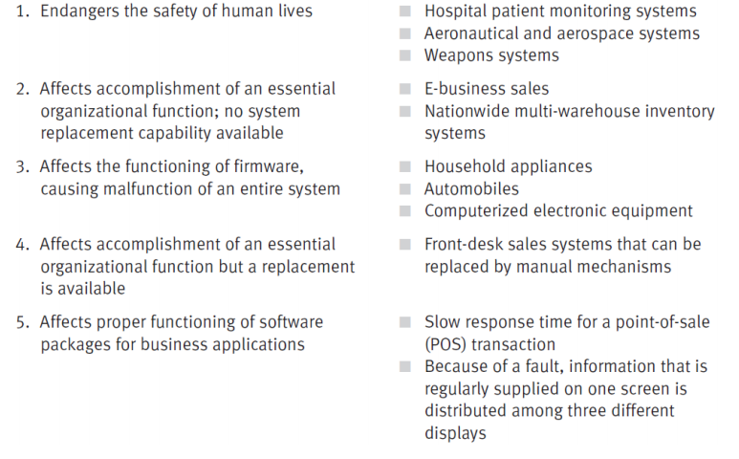

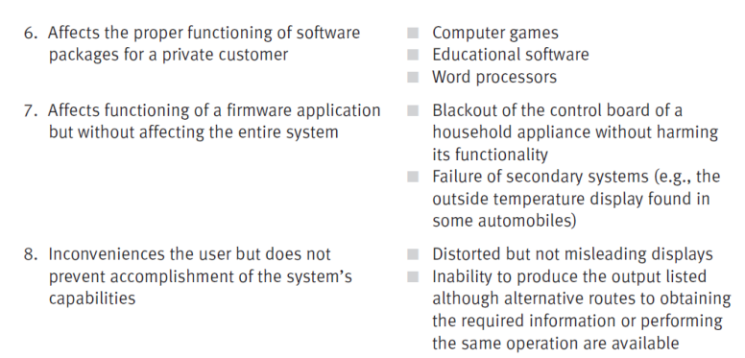
Damages to software developers
◆ Financial losses
◆ Damages paid for physical injuries – plus law sue
◆ Damages paid to organizations for malfunctioning of software
◆ Purchase cost reimbursed to customers
◆ High maintenance expenses for repair of failed systems
◆ Non-quantitative damages
◆ Expected to affect future sales
◆ Substantially reduced current sales

Rating Units, Integrations, and Applications
◆ We need to rate above things to determine their priority in
the testing plan.
◆ Rating based on two factors:
◆ Damage severity level – severity of results if module/application fails.
- How much damage is done??
- Will it destroy our business? Our reputation??
◆ Software risk level – Probability of failure.

Issues affecting software risk level

Module/application issues
■ Magnitude
■ Complexity and difficulty
■ Percentage of original software (vs. percentage of reused software)
Programmer issues
■ Professional qualifications
■ Experience with the module’s specific subject matter
■ Availability of professional support (backup of knowledge and experience)
■ Acquaintance with the programmer and the ability to evaluate his or her
capabilities.

It is important to note that the issues raised represent a specific case of
the general problem of determining the adequate intensity of quality assur
ance activities discussed in Section 7.2. Therefore, their underlying logic
reaches beyond software testing priorities.
Generating a combined rating based on the two factors
The combined rating C will be based on the ratings for A (the damage sever
ity grading) and B (the risk severity grading). C can be calculated in a variety
of ways, for instance:
C = A + B
C = k × A + m × B
C = A × B
where k and m are constants. The inclusion of a unit, integration or appli
cation in a testing plan and the amount of resources allocated to each test
depend on priorities as expressed in the combined rating. In order to deter
mine these priorities, initial calculation of the ratings is necessary. As a rule,
the higher the rating, the higher the testing priority and the greater the allo
cation for testing resources.
Implementation tip
Changes may be required in the testing plan as a result of:
■ Unavailability of resources.
■ Time requirements are too long and will cause the project to go beyond its
completion schedule.
■ Disagreements may arise about the evaluations of the expected damage
and risk severity levels and/or about estimates of time and resources
required for the testing activities.
The final testing plan will be completed only after these issues are resolved. Of
course, the plan may need to be updated as the project proceeds, to reflect
changes in conditions, including delays in project implementation.
Example
Super Teacher is a software package designed to support teachers in man
aging the grades of elementary school pupils. The package includes eight
applications. Ratings are required in order to plan the allocation of testing
resources for each application. Applications 7 and 8 are based on high per
centages of reused code. Application 2 was developed by team C,
composed of new employees. A five-level scale is used for rating damage
severity (Factor A) as well as software risk severity level (Factor B).
The combined rating for the application is calculated according to three
different methods:
(1) C = A + B
(2) C = 7 × A + 2 × B
(3) C = A × B
The applications and their single-factor and combined ratings, are presented
in Table 10.2.
When examining the results, it is noteworthy that the two highest prior
ities were both determined in the same order by all three methods of
calculating the combined rating.
Which sources to use for test cases?
The planners should consider which of the two main sources of test cases –
samples of real-life test cases and/or synthetic test cases – are most appro
priate to their needs. Each component of the testing plan, dealing with unit,
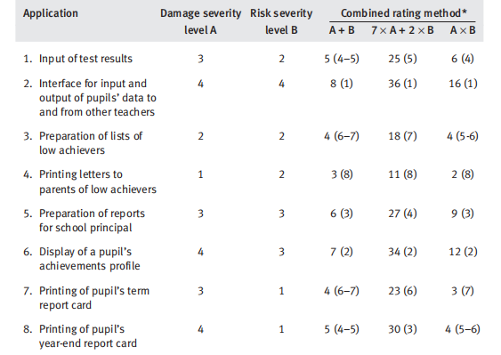
integration or the system test, requires an individual decision about the
respective test cases and their source:
■ The use of a single or combined source of test cases or both
■ How many test cases from each source are to be prepared
■ The characteristics of the test cases.
We shall return to the subject of test cases later

When are tests terminated?
The decision about the stage at which software testing should be terminated
is meaningful mainly with respect to system tests. The following five alter
native routes are available, each chosen on the basis of different criteria.
(1) The completed implementation route. According to this route, testing is
terminated once the entire test plan has been carried out and error free
(“clean”) results are achieved for all the required regression tests. This alter
native applies the perfection approach, which disregards budget and
timetable constraints.
(2) The mathematical models application route. When following this
route, mathematical models are applied to estimate the percentage of
undetected errors, based on the rate of error detection. Testing would be
terminated once the error detection rate declines below the rate that corre
sponds to a predetermined level of undetected errors which is considered
an acceptable software quality standard. The disadvantage of this route
is that the mathematical model chosen may not fully represent the project’s
characteristics; hence, reliance on this model may undermine the usefulness
of the tests because they will be terminated either too early or too
late. Another deficiency of this approach arises when the model either cho
sen or available does not supply estimates about the severity of the
undetected errors.
(3) The error seeding route. According to this approach, errors of various
types are seeded (hidden) in the tested software prior to the outset of
testing. The underlying assumption of this route is that the percentage of
discovered seeded errors will correspond to the percentage of real errors
detected. Accordingly, testing will terminate once the residual percentage
of undetected seeded errors reaches a predefined level considered accept
able for “passing” the system. Besides the additional workload for the
testers, the main deficiency of this approach lies in the experience
upon which it is based. While the testers are expected to face “new and
original” errors in every new project, the seeding plan is totally based on
past experience. As experience with each system differs, the seeding
method can not accurately estimate the residual rate of undetected errors
in unfamiliar systems.
(4) The dual independent testing teams route. If this route is adopted, two
teams implement the testing process independently. By comparing the lists of
detected errors provided by each team, the number of errors left undetected
is estimated as follows.
The teams’ achievements yield:
Na = number of errors detected by team A
Nb = number of errors detected by team B

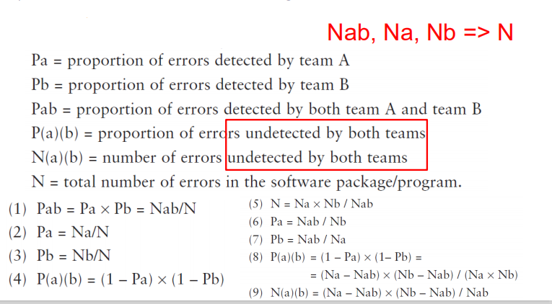

The following count of detected errors is arrived at after comparison of
the lists:
Nab = number of errors detected by both team A and team B.
We would expect to find:
Pa = proportion of errors detected by team A
Pb = proportion of errors detected by team B
Pab = proportion of errors detected by both team A and team B
P(a)(b) = proportion of errors undetected by both teams
N(a)(b) = number of errors undetected by both teams
N = total number of errors in the software package/program.
Assuming statistically independent testing by the teams and random detec
tion of errors, simple probability equations can be applied that yield
estimates of P(a)(b), N and N(a)(b). For this purpose we define:
(1) Pab = Pa × Pb = Nab/N
(2) Pa = Na/N
(3) Pb = Nb/N
(4) P(a)(b) = (1 – Pa) × (1 – Pb)
Simple mathematical manipulation of equations (1), (2), (3) and (4) above
yields the following results:
(5) N = Na × Nb / Nab
(6) Pa = Nab / Nb
(7) Pb = Nab / Na
(8) P(a)(b) = (1 – Pa) × (1– Pb) =
= (Na – Nab) × (Nb – Nab) / (Na × Nb)
(9) N(a)(b) = (Na – Nab) × (Nb – Nab) / Nab
Example: The developers of Super Magic, an electronic game for children
aged 4–7, have decided to employ the dual test method. They determined
their testing termination level to be residual undetected errors of 2.5%. As a
complementary “tool” for identifying the undetected errors, they planned
wide application of beta site testing (see Section 10.4) before beginning the
marketing of Super Magic.
The testing teams summarized their achievements after eight weeks of
testing and regression testing as follows:
Team A detected 160 errors (Na = 160)
Team B detected 180 errors (Nb = 180).
Comparison of the detected errors of the two teams yielded the following
result:
Nab = 144
Application of the probabilistic model (equations. (8), (9) and (5) above) yields:
P(a)(b) = 16 × 36 / (160 × 180) = 0.02
N(a)(b) = 16 × 36 / 144 = 4
N = 160 × 180 / 144 = 200
According to the above results, only 2% of the total number of errors were
undetected; testing may therefore be terminated at this stage.
Applying equations (6), (7), (9) and (5) yields the following results: team
A detected 80% of the total number of 200 program errors, while team B
detected 90% of the total number of errors. Together, the two teams suc
cessfully detected 196 out of the estimated total number of 200 errors,
leaving four undetected errors.
The main deficiency of the dual testing method is that, by definition, it
can be applied only to projects where two independent testing teams are
employed for the same project. Another deficiency lies in the assumption of
random detection of errors. Its methodological basis may be questioned in
some cases, especially where both teams share similar testing experience and
employ the same testing methodology.
(5) Termination after resources have petered out. Termination of this type
occurs when budgets or the time allocated for testing run out. This situation,
unfortunately not uncommon in the software industry, is, of course, undesirable.
Implementation tip
Once you consider terminating testing, whether on the basis of a mathematical
model, the error seeding route, or the dual testing teams route, validation of
the accuracy of the results within your organization’s testing environment is of
highest importance.
Systematic follow-up is required for validation:
(1) Data collection. Collection of quality data on the errors detected in the
project: total number of code errors = errors detected in the testing
process + errors detected by the customer and the maintenance team
during the first 6 or 12 months of regular software use.
(2) Analysis of the error data. The analysis will compare estimates
suppliedby the models with the real figures.
(3) Comparative analysis of severity of errors. Errors detected in the testing
process are compared to errors detected by the customer and the
maintenance team during the first 6 or 12 months of regular software use.
Test planning documentation
The planning stage of the software system tests is commonly documented
in a “software test plan” (STP). A template for the STP is presented in
Frame
The software test plan (STP) – template
1 Scope of the tests
1.1 The software package to be tested (name, version and revision)
1.2 The documents that provide the basis for the planned tests (name and
version for each document)
2 Testing environment
2.1 Testing sites
2.2 Required hardware and firmware configuration
2.3 Participating organizations
2.4 Manpower requirements
2.5 Preparation and training required of the test team
3 Test details (for each test)
3.1 Test identification
3.2 Test objective
3.3 Cross-reference to the relevant design document and the requirement
document
3.4 Test class
3.5 Test level (unit, integration or system tests)
3.6 Test case requirements
3.7 Special requirements (e.g., measurements of response times, security
requirements)
3.8 Data to be recorded
4 Test schedule (for each test or test group) including time estimates for the
following:
4.1 Preparation
4.2 Testing
4.3 Error correction
4.4 Regression tests
The test design is carried out on the basis of the software test plan as docu
mented by STP. The test procedures and the test case database/file may be
documented in a “software test procedure” document and “test case file”
document or in a single document called the “software test description”
(STD). A template for the STD is presented
Software test descriptions (STD) – template
1 Scope of the tests
1.1 The software package to be tested (name, version and revision)
1.2 The documents providing the basis for the designed tests (name and
version for each document)
2 Test environment (for each test)
2.1 Test identification (the test details are documented in the STP)
2.2 Detailed description of the operating system and hardware configuration
and the required switch settings for the tests
2.3 Instructions for software loading
3 Testing process
3.1 Instructions for input, detailing every step of the input process
3.2 Data to be recorded during the tests
4 Test cases (for each case)
4.1 Test case identification details
4.2 Input data and system settings
4.3 Expected intermediate results (if applicable)
4.4 Expected results (numerical, message, activation of equipment, etc.)
5 Actions to be taken in case of program failure/cessation
6 Procedures to be applied according to the test results summary
Test implementation
Commonly, the testing implementation phase activities consist of a series of
tests, corrections of detected errors and re-tests (regression tests). Testing is
culminated when the re-test results satisfy the developers. The implementa
tion phase process is illustrated in Figure 10.2.
The tests are carried out by running the test cases according to the test
procedures. Documentation of the test procedures and the test case data
base/file comprises the “software test description” (STD), presented in
Frame 10.3.
Re-testing (also termed “regression testing”) is conducted to verify that
the errors detected in the previous test runs have been properly corrected,
and that no new errors have entered as a result of faulty corrections. It is
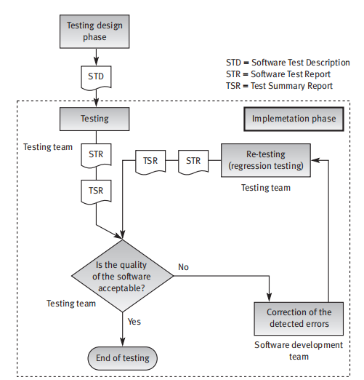

quite common to find that the correction-regression testing sequence is
repeated two to four times before satisfactory test results are achieved.
Usually, it is advisable to re-test according to the original test procedure.
However, in many cases, especially in manual software tests, only a portion
of the original test procedure is re-tested to save testing resources and short
en re-testing duration. The parts of the software system omitted are those
where no errors were detected or where all the detected errors were proper
ly corrected at a previous point. Partial reruns of the test procedure save
resources and time but involve the risk of not detecting new errors uninten
tionally introduced in the omitted parts during erroneous correction of the
errors found in other parts of the software. The results of the individual tests
and re-tests are documented in a “software test report” (STR). A template
for the STR is presented in Frame 10.4.
The summary of the set of tests planned for a software package (or
software development project) is documented in the “test summary
report” (TSR).

Super Teacher – Alternative Combined Rating
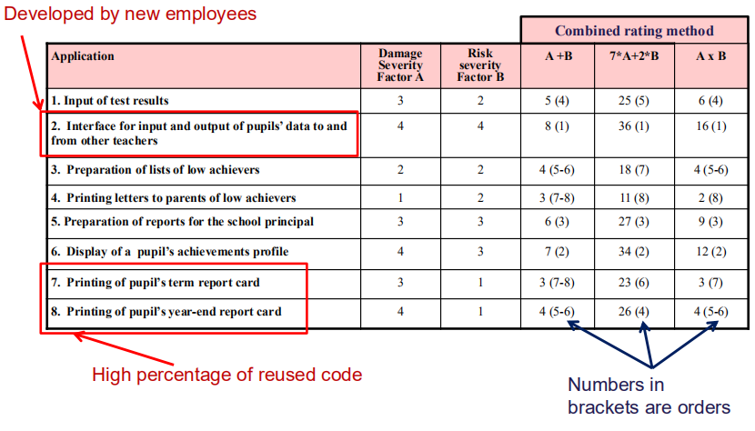

Which sources should be used
◆ Do we use live test cases or synthetic test cases.
◆ Use live data or contrived (dummy) data??
◆ What do you think??
◆ Also need to consider single/combined tests and the
number of tests. Do test cases evolve into more inclusive
tests?
◆ How about if the testing is top down? Bottom up? What
sources do you think might be needed then??

Test Case Design
Introduction
◆ A Test Case is a documented set of
◆ data inputs
◆ operating conditions
◆ Required to run a test item together with the expected
results of the run.
◆ The tester runs the test case documentation and compare
results with expected results.
◆ Reports are generated documenting results of the testing.

Test Case Design
◆ Generally, equivalence class testing is used to measure
effectiveness of tests (Black Box testing)
◆ Frequently, there are formulas included in the
specifications. Many of these have ‘categories’ of values
to be tested.
◆ Example:
◆ Houses < $100,000
◆ House > $100, <= $300,000
◆ Houses > $300,000 and <= $750,000
◆ Houses > $750,000
◆ Such that each of these have formulas for computing

◆ Then, anticipated results are also specified.
◆ Likely edits include:
◆ Specifically cited unacceptable values
◆ Ranges of permissible values
◆ Error messages to be generated upon detecting incorrect inputs
or computations, and more.
◆ Compatibility edits
◆ Associativity edits
◆ Etc. …...

Real time test case designs use different sets of
parameters:
◆ Temperature settings
◆ Pressure gauges settings
◆ Alarm settings
◆ Warning lamps
◆ Bells and other alarms
◆ Expected (or prescribed) actions that must occur.
◆ These must all be tested especially for critically-important
real-time systems possibly affecting life, security, safety,

Test cases – types of expected results
Management information systems - expected results:
◆ Numerical
◆ Alphabetic (name, address, etc.)
◆ Error message. Standard output informing user about missing data,
erroneous data, unmet conditions, etc.
Real-time software and firmware - expected results:
◆ Numerical and/or alphabetic massages displayed on a monitor’s screen
or on the equipment display.
◆ Activation of equipment or initiation of a defined operation.
◆ Activation of an operation, an alarm, warning lamps and the like as a
reaction to identified threatening conditions.
◆ Error message. Standard output to inform the operator about missing
data, erroneous data, etc
Test case sources
◆ Random and synthetic test cases (i.e., simulated
test cases)
◆ Need user/client inputs or client representatives to help out here
serve as test designers.
◆ Random samples of real life cases and
Stratified sampling of real life cases (Preferable)
◆ Obtain ‘live’ data if at all possible
Test case sources

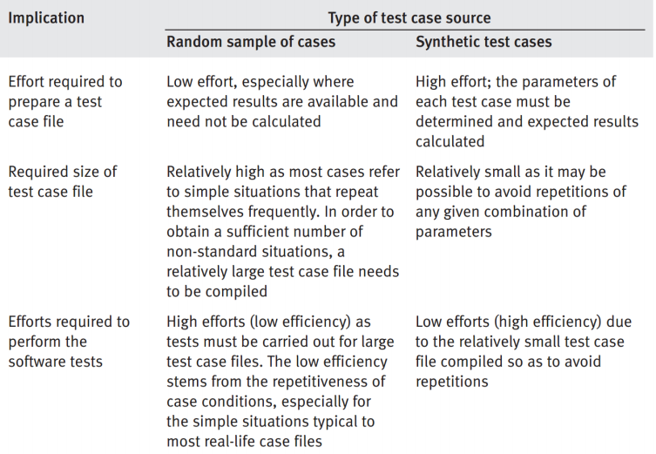

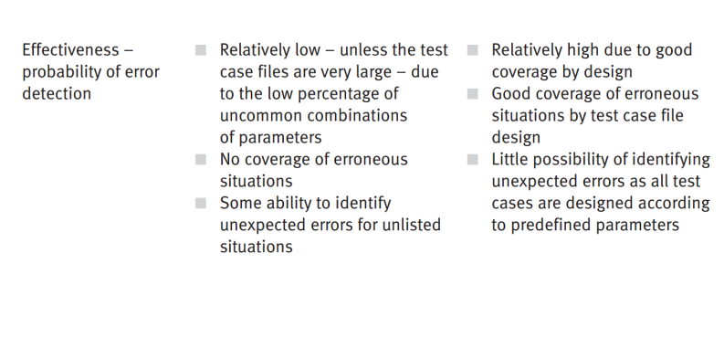
Test case sources - stratified sampling
◆ To increase the sampling proportion of small populations
and high potential error populations
◆ Stratified sampling improves coverage of less frequent
and rare conditions.
◆ Stratified sampling allows us to break down a random
simple into sub-populations of test cases;

Test case sources - stratified sampling
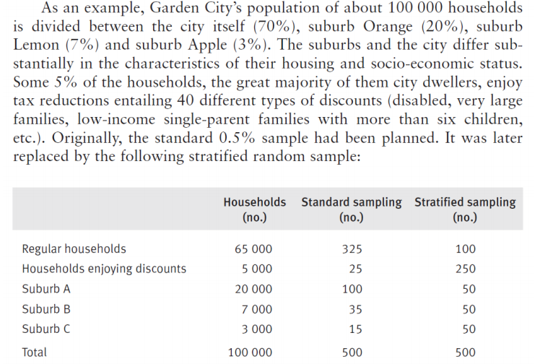

Automated Testing
◆ Use computerized CASE tools - computer aided software
engineering
◆ Improves testing considerably but at a cost.
◆ Can perform many tests, especially loading tests
- normally not feasible w/o some automated help.
◆ CASE tools can provide much statistical reporting,
speed up testing, and much more.
We will look at:
◆ The process of automated testing
◆ The types of automated tests
◆ The advantages and disadvantages of automated tests

Process of automated testing
◆ Requires test planning, test design, test case
preparation, test performance, test log and report
generation, re-testing after corrections
(regression) and final test log and report
preparation
◆ May iterate several times
◆ Requires an immense commitment of manpower.
◆ Manpower availability may be a limiting factor in
choosing to go with automated testing

Types of Automated Tests
◆ Mainly used for testing tasks with high number of
regression tests and performing test classes not feasible
for manual testing such as load testing
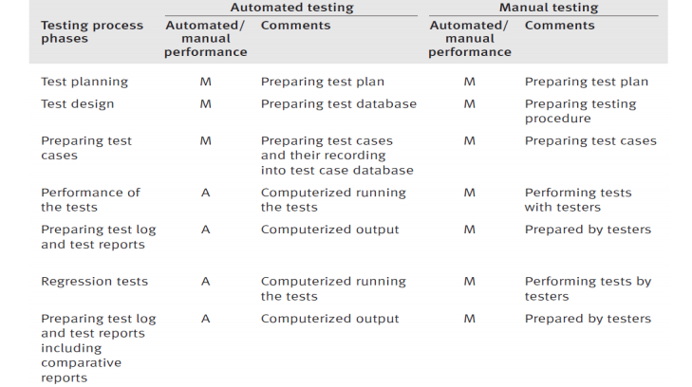

Automated Tests – Code Auditing
◆ Computerized code auditor checks for compliance of
code to standards.
◆ Lists of variations and statistical data are reported.
Can check:
◆ Module size
◆ Levels of loop nesting
◆ Levels of subroutine nesting
◆ Prohibited constructs, such as GOTO
◆ Naming conventions for variables, files, etc.
◆ Unreachable code lines of program or subroutines
◆ Can locate comments, and more.

Automated tests – coverage monitoring

◆ Produce reports about line coverage achieved
when implementing a given test case file.
◆ Reports on percentage of lines covered by test
cases as well as listing of uncovered lines.
◆ Vital for white box testing.

Automated tests – functional tests

◆ Automated functional testing often replaces manual
black-box correctness tests.
◆ Documentation provides listings of errors identified and
summaries and statistics required by testers’
specifications.
◆ After fixing the program, much testing is redone
(regression testing).
◆ This is to ensure the fixes have not adversely affected
other correctly-functioning code.

Automated testing - functional tests: comparator
◆ Regression tests can be done with minimal effort because
we already have the existing test case database.
◆ Often use a test case comparator in regression testing.
◆ This accommodates automated comparisons of
successive tests with results of functional testing tools
that enables testers to prepare an improved analysis of
the regression test results.
◆ Quite common to require three or four regression tests
before qualifying as satisfactory.

Automated testing - functional tests: load testing
◆ Huge plum for automated testing.
◆ Great for testing large numbers of users or large numbers
of inputs in real time systems.
◆ Only practical way to carry out load testing is via
computerized simulations where the real load conditions
can be monitored.
◆ Computerized monitoring of the load tests produces
software system performance measurements in terms of
reaction time, processing time, and other desired
parameters.
◆ These are compared with the specified maximal load
performance requirements in order to evaluate how well
the software system will perform in daily use.

Test Management
◆ Testing usually involves monitoring test results.
◆ Computerized test management supports
monitoring and other testing management goals.
◆ Computerized test management tools are
planned to provide testers with reports, lists, and
other types of information at levels of quality and
availability that are higher than those provided by
manual test management systems.

Test Management
◆ Some computerized test management packages provide both
automated and manual components and automated components for
the automated testing only.
Many features are both automated and manual:
◆ Test Plans, Test Results and Correction Follow up
◆ Preparation of lists, tables, and visual presentations of test plans
◆ List of test cases
◆ Listing of detected errors
◆ Listing of correction schedule (performer, date of completion, etc.)
◆ Listing of uncompleted corrections for follow up.
◆ Error Tracing: detection, correction and regression tests.
◆ Many test tools provide for both automated and manual testing.

Availability of Automated Testing Tools

◆ Most are highly specialized for specific areas of
programming and applications:
◆ Client-server systems
◆ C/C++ applications
◆ UNIX applications
◆ A specific software house’s ERP (Enterprise
Resource Planning) applications, …
Advantages of Automated Testing
◆ Accuracy and completeness of performance
Manual testing suffers from periods of tester weariness or low
concentration, traits, …
◆ Accuracy of results log and summary reports
Manual testing sometimes do not recognize errors and overlook
others in their logs…
◆ Comprehensiveness of information
Results stored in databases and very available
Improved error information
◆ Fewer manpower resources required
Manual performance of testing is a major consumer of resources
◆ Shorter duration of testing
Far shorter than manual testing. Can be carried out uninterrupted
24=7.

Advantages of Automated Testing
◆ Performance of complete regression tests
- Manual tests not always conducted as widely as they should.
- Automated tests are more complete and easier to rerun tests based
on previous results
- Substantially reduced the risk of not detecting errors introduced
during previous rounds of corrections.
◆ Performance of test classes beyond the scope of manual
testing
- Can also perform special tests otherwise not too feasible, such as
load testing, availability testing, and more.
- These tests are almost impossible to perform manually on systems
of large size.

Disadvantages of Automated Testing
◆ High investments required in package purchasing and
training
◆ High package development investment costs.
- Packages do not always meet consumer needs and thus custom
made packages may need to be developed.
◆ High manpower requirements for test preparation.
- Higher than those required for preparing for manual testing of the
same package.
◆ Considerable testing areas left uncovered
- This forces testers to mix manual and automated testing in their test
plans.

Alpha and Beta Testing Programs
◆ Designed to solicit inputs from potential users.
◆ Also used to find software design and coding
errors from COTS(commercial over-the-counter sale).
◆ In a way, alpha and beta site testing replace the
customer’s acceptance test that is impractical
under the conditions of commercial software
package development.
◆ These should not replace the formal software
tests performed by the developer.

Alpha Tests
◆ Software testing performed at developer’s site.
Customer, by applying the new software to the
specific requirements of his organization, tends
to examine package from angles not expected by
the testing team.
◆ Errors identified are expected to include errors
only a real user can reveal and thus should be
reported to the developer.

Beta Test
◆ Much more commonly applied.
◆ Once an advanced version of the software package is
available, the developer offers it free of charge to one or
more potential users.
◆ Users install package in their sites (beta sites) with the
understanding that they will inform the developer of all
errors revealed during trials or regular usage.
◆ Sometimes developers involve hundreds or even
thousands of participants in the process.

Advantages of Beta tests
◆ Identification of unexpected errors.
- Users usually test in different ways and apply the software in ways
different than the developer’s scenarios. Results in errors not found
◆ A wider population in search of errors.
- Wider range of participation contributes a scope of software usage
experience and potential for revealing hidden errors that go beyond
those available at the developer’s testing site.
◆ Low costs.
- Participants are not paid for information they report. Only costs is for
the package and in most cases this is quite low.
Disadvantages of Beta tests
◆ A lack of systematic testing
- Testing is sporadic and many parts may go well untested.
- Reports are not required to be ‘orderly.’
◆ Low quality error reports
- Participants are not professional testers
◆ Difficult to reproduce the test environment
- Usually beta testing done in an uncontrolled testing environment and
this makes it difficult to reproduce.
◆ Much effort is required to examine reports
- High investment in time and human resources to examine reports
due to frequent repetitions and low quality of reporting.

Good Tips

◆ Testers and developers should be especially cautious
when applying beta site testing.
◆ Beta site testing of pre-matured software may detect
many software errors but can result in highly negative
publicity among potential customers.
◆ These negative impressions can reach the professional
journals and cause substantial market damage.

Recommendation:
◆ Alpha site testing be initiated first, and
◆ Beta site testing be delayed until the alpha test site tests
have been completed and their results analyzed.

